Horsham City Urban Renewal
A plan for key development sites

Horsham Rural City Council is planning for the long-term future of the regional city. The aim is to transform and revitalise the city to make it a more attractive place to live, work, visit and invest in. This forms part a suite of strategic projects being undertaken concurrently by Council with a view to creating a brighter future for Horsham over the coming decades.
The recently completed Horsham: City to River Vision & Masterplan sets out a long term Vision and Masterplan for central Horsham and will be used to guide the revitalisation of the area over the next 20 to 30 years.
A key action of the Masterplan was the identification of a number of sites and precincts suitable for urban renewal to encourage residential, commercial, mixed use and development. The Horsham City Urban Renewal Project seeks to facilitate the development of these identified precincts through market testing, rezoning and setting a clear vision and design guidelines.
Horsham is the major provider of retail, community and government services in the Wimmera. It is is undergoing moderate growth associated with government services, a strong agricultural sector and diversification in manufacturing, renewable energy and mining. A planning response is required that addresses housing diversity and investment for the future. It is anticipated the Horsham City Urban Renewal Project will provide a new and attractive mixed use precinct in response to growth and change occurring in the Wimmera..
At present, these key sites have a mix of historical, commercial and industrial land uses which pose a significant challenge to redevelopment in a regional setting. Planning and development assistance is required to unlock this land for the growth of Horsham city.

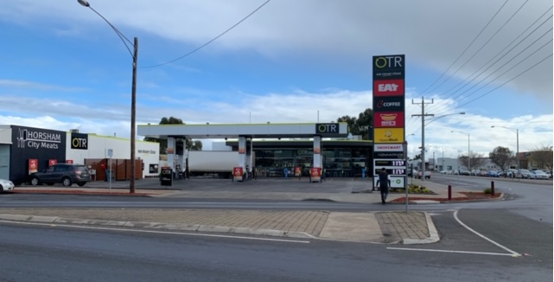

The Development sites
The Urban Renewal study area extends from the Wimmera River to the south to Ballie Street to the north and encompasses the Horsham Central Activities District (CAD). The identified urban renewal development sites and precincts which are the subject of this Project Brief include:
- Investigation area 1 - Council Depot and adjoining community uses, 22-32 Selkirk Drive (land area: 2.19 ha.). An existing operational Council Depot which has been identified for relocation. The site is currently zoned General Residential Zone 2 (GRZ2).
- Investigation area 2 - Land north of Selkirk Drive and the HRCC Council Depot site (land area: 4.39 ha.). Land comprises a range of commercial and industrial uses including a Concrete batching plant and vacant industrial land which is considered to be inappropriately located. The site is currently zoned Commercial 1 (C1Z).
- Investigation area 3 - Commercial land bounded by Firebrace Street, Madden Street, Baker Street and the Botanical Gardens and Harvey Norman retail premises (land area: 1.62 ha.). The land comprises a mix of vacant land, residential housing and commercial uses and is currently zoned Commercial 1 (C1Z) and General Residential Zone 2 (GRZ2).

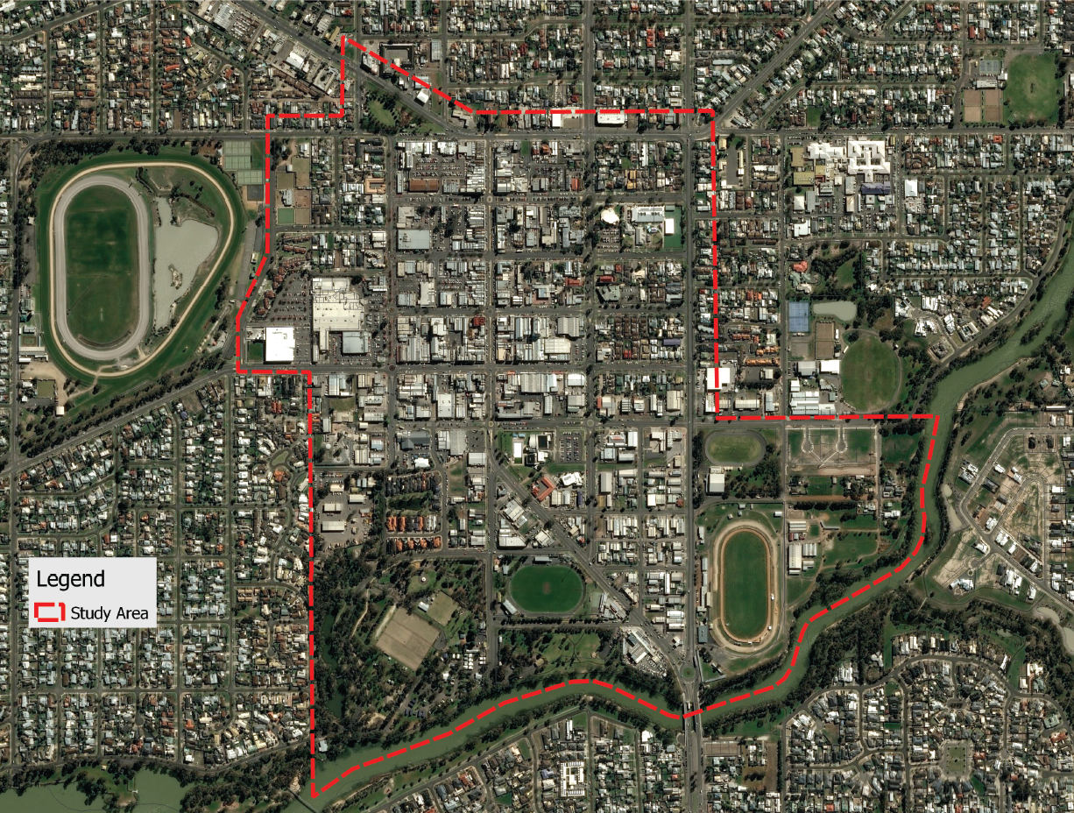
Investigation Area 3: Commercial/ residential landholdings north of Baker Street
Investigation Area 1: Council Depot site
Investigation Area 2:
Concrete batching plant and surrounding commercial landholdings
2
3
1
Legend
Masterplan
Study area

Urban renewal
Investigation
areas
N
2

Why is the project needed?
As part of the staged implementation of the Urban Renewal Vision and Masterplan, Council is seeking to implement potential development outcomes based on commercial and financial assessments, detailed site analysis and stakeholder engagement. This will the future planning and development of the selected urban renewal investigation areas.
The project will build upon the strengths of Horsham as a Regional Centre and facilitate the transformation of the city through:
- Providing a guide for urban renewal of the city to accelerate the delivery of public and private development
- Provision of housing choice and diversity;
- Ensure a land supply pipeline to facilitate regional growth;
- Commercial and financial feasibility and master planning to support development outcomes for these strategic sites;
- Develop strategies to overcome commercial and environmental barriers to development;
- Concept Development Plans;
- Achieve vibrant mix of commercial and residential activity;
- Develop linkages between the city and river; and
- Provide Urban Design guidance for the precincts.

The project will assist in facilitating the redevelopment of key sites and provide a model for urban renewal in regional Victoria.

What will the project deliver?
The project will develop plans for the development sites including:
- Identify constraints to future use and development, including desktop technical investigations of current statutory planning controls, environmental, services and infrastructure, traffic and other physical constraints.
- A comprehensive commercial and property market review into future sustainable uses including residential, mixed use commercial uses.
- Targeted Stakeholder and Community Engagement, including adjoining and affected landowners, servicing authorities and Council.
- Redevelopment plan options - preparation a financial model of potential commercial development options for the Investigation areas including:
- Indicative redevelopment plans for the investigation areas identifying likely land use mix, subdivision layout, development density/ yield.
- Financial feasibility analysis of potential commercial outcomes for the Investigation areas, including justification for the assumptions adopted in the financial models and sensitivity analysis.
- Planning Scheme implications and recommendations.
- Preparation of a Final Redevelopment Plans and an Action/ Implementation Plan including:
- Final redevelopment plans outlining preferred option identifying land use, mix, lot layout, development density/ yield and potential building form.
- Commercial feasibility analysis of preferred options and key sites.
- Planning Scheme recommendations to guide future development
- An action and Implementation plan for each investigation area including recommendations of supporting actions to facilitate and progress redevelopment.

Next Steps
The project will be delivered by Horsham Rural City in partnership with the Victorian Planning Authority and consultants with experience in commercial and property feasibility, town planning, urban design and infrastructure to support investigations and analysis of potential development.
The project will be delivered in a number stages involving landholder engagement, feasibility, options assessment and concept plan to ensure the future development of Horsham City Urban Renewal is feasible and delivers on the future needs of the city.
Project budget of $120,000 - (Council contribution $50,000).

