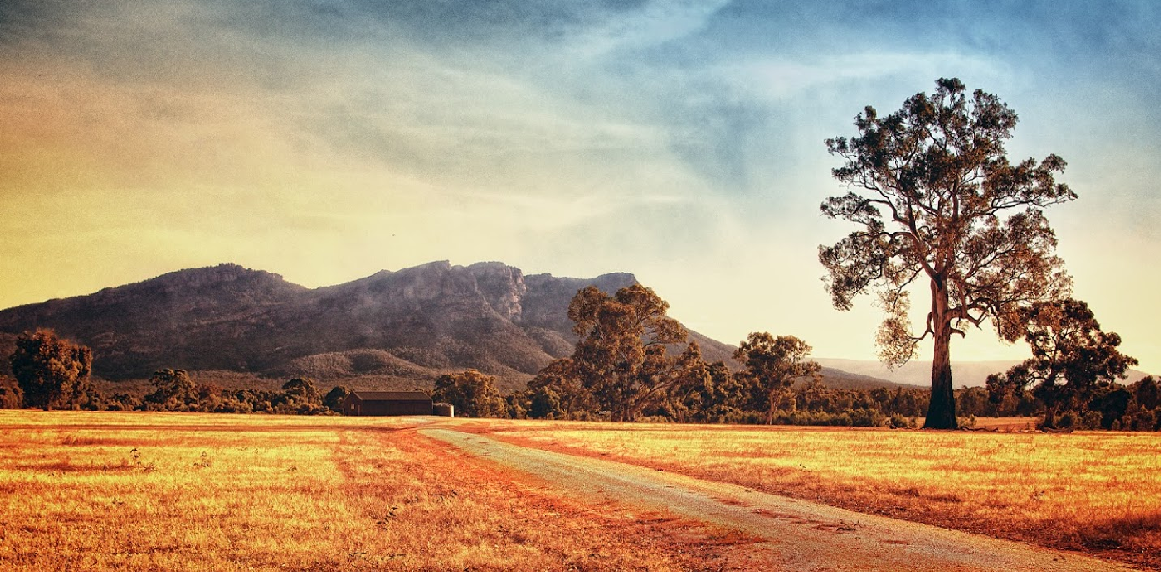
WARTOOK VALLEY STRATEGY

September 2017

Prepared For:

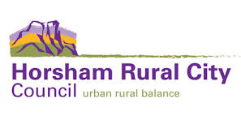

Copyright

© Meinhardt

This document is subject to copyright. Use or copying of this document in whole or part without the written permission of Meinhardt constitutes an infringement of copyright.

Disclaimer

Information in this document is current at the time of writing. While all professional care has been undertaken in preparing the document, Meinhardt accepts no liability for loss or damages incurred as a result of reliance placed upon its content.

The mention of any company, product or process in this report does not constitute or imply endorsement by Meinhardt.

Recognition of our lands traditional owners

The Horsham Rural City Council recognises the five Traditional Owner groups of this land: the Wotjobaluk, Wergaia, Jupagulk, Jaadwa and Jadawadjali people.

Rev. no. | Document purpose | Project Planner | Approved for issue
 |  |  | Approved by | Signature | Date
01 | Draft Report | Alicia Burnett | Tom Harrington
02 | 2nd Draft Report | Edwin Irvine | Colin Kemp |  | January 2016
03 | Consultation draft | Edwin Irvine | HRCC |  | March 2016
04 | Final for adoption | Edwin Irvine | Angela Murphy |  | September 2017

TABLE OF CONTENTS
TABLE OF CONTENTS 3
Part 1: Introduction 4
1.1 Executive Summary 4
1.2 What is the Wartook Valley Strategy? 5
1.3 Structure of this Document 6
1.4 How was the Wartook Valley Strategy Prepared? 7
1.5 Consultation 8
1.6 Location 9
1.7 Planning Background 11
1.8 Summary of Key Issues 12
Part 2: The Strategy 14
2.1 Vision 14
2.2 Principles 14
2.3 Settlement and Housing 15
Figure 2 Wartook Valley Land Supply by Lots Size 16
2.4 Environment 19
2.5 Landscape 22
2.6 Economics and Tourism 25
2.7 Transport and Infrastructure 28
2.8 Sustainability 29
2.9 Proposed Precincts 31
Figure 4: Proposed Precincts 31
2.10 Conclusion 32
Part 3: Implementation 33
3.1 Implementation Plan 34
3.1.1 Review of Existing Planning Provisions 34
Table 1: Review of Existing Planning Scheme Controls 34
3.2 Implementation 39
3.2.1 Local Planning Policy Framework 39
3.2.2 Recommended Zoning 43
Table 3: Precinct Descriptions 44
3.2.3 Recommended Overlays 54
Table 4: Recommended Changes to Overlays 54
3.3 Design Guidelines 55
3.4 Future Work 55
Part 4: Wartook Valley Strategy Design Guidelines 57

Part 1: Introduction

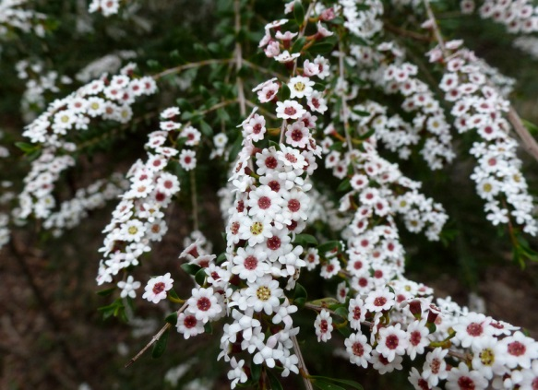
1.1 Executive Summary
The Wartook Valley Strategy has been developed to resolve the conflicts within the Planning Controls which affected the Study Area. Developed by the Wartook Valley Working Group on behalf of Horsham Rural City Council, the Wartook Valley Strategy articulates a Vision for the area, and defines the Principles, Objectives and Strategies which will be used in order to achieve the Vision.

The initial Draft Vision Principles, Objectives and Strategies were presented for consultation which ran from 22 May to 23 June 2015. The Vision Principles, Objectives and Strategies contained within this document have been revised based on the feedback received during that consultation.

The work undertaken on the project has identified that the Environmental and Landscape Values of the Wartook Valley are of critical importance, and it is these elements which have driven the future vision and preferred outcomes as articulated within this Strategy.

It has also been recognised that the Grampians Peaks Trail and Wartook to Zumsteins Cycling/Walking Trail provide new opportunities to support existing and leverage new tourism businesses, and the Wartook Valley Strategy seeks to support these new uses where they are consistent with the identified Environmental and Landscape Values.

Furthermore, it was recognised that the area supported existing rural lifestyle opportunities, which are inconsistent with the purpose of the existing Farming Zone. This Strategy provides an opportunity to recognise the existing rural lifestyle attributes of the Study Area, whilst acknowledging environmental risks associated with flooding and bushfire.

1.2 What is the Wartook Valley Strategy?

The Wartook Valley Strategy has been prepared on behalf of the Horsham Rural City Council.

The Wartook Valley is an area of high landscape, environmental and rural values, which have combined to make the area an attractive place to live, work and recreate. Located adjacent to the Grampians National Park and Wartook State Forest, and within close proximity to numerous other state parks such as the Black Range State Park, the area contains areas of significant ecological and landscape values.

This Strategy identifies and articulates a vision for the area and provides direction to resolve potential land use conflicts and ensures the ongoing use and development of the area occurs in a way that does not detract from the local Environmental and Landscape Values.

Development within Wartook is both dispersed and centralised with areas of rural residential development, interspersed with farming (grazing), intensive agriculture (wildflower plantations) and tourism (holiday parks, B&B’s and lodges). Tourism uses associated with and benefiting from proximity to the Grampians National Park are dotted throughout the Wartook Valley.

Successive amendments to Victoria’s planning system has led to the situation where a disconnect has developed between the Horsham Planning Scheme and these diverse land uses and development patterns. Review of the existing planning controls is required to ensure the Horsham Planning Scheme provides greater guidance for the area, ensuring that ongoing land use and development occurs in a manner that is consistent with the social, environmental and economic needs of the Wartook Valley.

The future direction for the Wartook Valley must reconcile differing opinions on how to:

- Protect the National Park and the most appropriate method to do so;
- Apply more conservation focused planning controls;
- Allow for greater tourism activity associated with the area; and
- Protect and retain farming land and other agricultural uses in the area.

The Wartook Valley Strategy will be implemented through changes to the Horsham Planning Scheme.

1.3 Structure of this Document

This document has been broken into the following Sections:

- Part 1: Introduction
- Part 2: The Strategy
- Part 3: Implementation

Part 1 provides an introduction to the Wartook Valley Strategy, outlining the relevant history, the methodology of how the Strategy was prepared, the intent of the document and an outline of the steps undertaken to finalise the project.

Part 2 contains the work produced as part of the project.

Section 2.1 identifies the Vision or a statement of the preferred future for the Wartook Valley. The Vision describes the goals, desires and attributes for a place and a future to strive for.

Section 2.2 articulates the principles that provide overarching direction and high level strategy for the Wartook Valley Strategy.

Section 2.3 through to Section 2.8 details the Objectives and Strategies of the Wartook Valley Strategy. The Objectives define what we are seeking to achieve. The Strategies identify how the Objectives are going to be achieved.

Section 2.9 identifies an Overall Plan, which spatially articulates the Vision, Principles, Objectives and Strategies.

Part 3 includes the Implementation Plan, Design Guidelines and Future Work.

The Implementation Plan makes recommendations for how to incorporate the Wartook Valley Strategy into the Horsham Planning Scheme.

The Design Guidelines provide guidance on the preferred design outcomes for future development within Wartook Valley.

The Future Work makes recommendations for future work which should be undertaken to assist in achieving the Vision of the Wartook Valley Strategy, or work which was identified in the process of developing the Wartook Valley Strategy.

1.4 How was the Wartook Valley Strategy Prepared?

The Wartook Valley Strategy was prepared by the Wartook Valley Strategy Working Group (the Working Group). The Working Group consisted of two local residents, two members representing businesses, two Council Officers, two Counsellors and two project facilitators.

The Working Group followed the following process:

1.5 Consultation
Council’s Community Engagement Template was consulted in the preparation of the Project Brief. The community engagement process mooted for this project utilises the “Involve (work with)” level of engagement. The objective of this process is to work directly with the public throughout the process to ensure that public concerns and aspirations are consistently understood and considered.

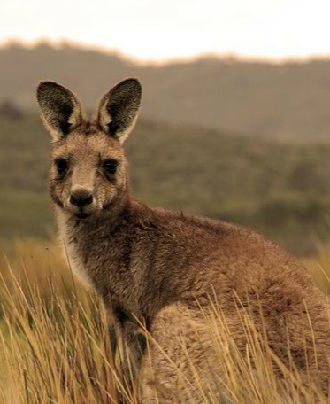
Consultation began in February 2015 with interviews conducted with tourism operators, businesses, landowners, and real-estate agents. This information was included in the Background Paper, which was the first document released in support of the Wartook Valley Strategy.

Applications for membership of the Working Group was then advertised, with applications assessed against a set of selection criteria. Appointments were made, and the Working Group commenced operations on 10 February 2015. All outputs and Working Group Meeting Notes were available online on the Horsham Rural City Council website, on a page dedicated to this project.

The Working Group considered the information in the Background Paper prior to undertaking the SWOT analysis, from which the draft Vision, Principles, Themes, Objectives and Strategies were derived. Formal consultation occurred on the Initial Draft Vision, Principles, Themes, Objectives and Strategies between 22 May 2015 and 23 June 2015. A number of changes were made to the draft based on the feedback received, and have now been incorporated into the Wartook Valley Strategy.

A Draft Wartook Valley Strategy was then prepared and presented for further consultation. The consultation period commenced on 24 March 2016 through to 29 April 2016, which also included a drop-in consultation event at the Laharum Hall on 12 April 2016. A further meeting with the community held on 25 July 2017 offered the opportunity for the community to speak directly to Councillors about their submissions. Submissions on the draft Strategy were considered by Council. This version of the Wartook Valley Strategy includes changes to the draft based on the submissions received.

The Wartook Valley Strategy includes an Implementation Plan that outlines how the Wartook Valley Strategy is to be implemented through the Horsham Planning Scheme. A Planning Scheme Amendment is required to make the recommended changes to the Horsham Planning Scheme. That amendment will be formally Exhibited (for further community comment) as per the requirements of the Planning and Environment Act 1987. Unresolved submissions would then be referred to an Independent Planning Panel appointed by the Minister for Planning.

1.6 Location

The Wartook Valley is located within the south-east corner of Horsham Rural City Council, which is within the Wimmera-Southern Mallee region of Victoria. It directly abuts the Grampians National Park to the east, and includes part of the Wartook State Forest to the west.

Northern Grampians Road provides the main access through the area, connecting Wartook Valley to Horsham, the region’s largest city. Wartook Valley is a 3½ hour drive from Melbourne and Geelong, a 2½ hour drive from Ballarat and a 5 hour drive from Adelaide. There are currently no VLine or public transport services to or within the Wartook Valley.

Figure 1: Study Area

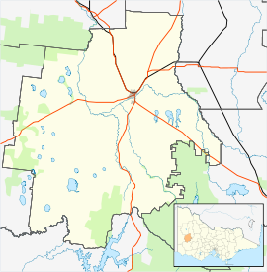
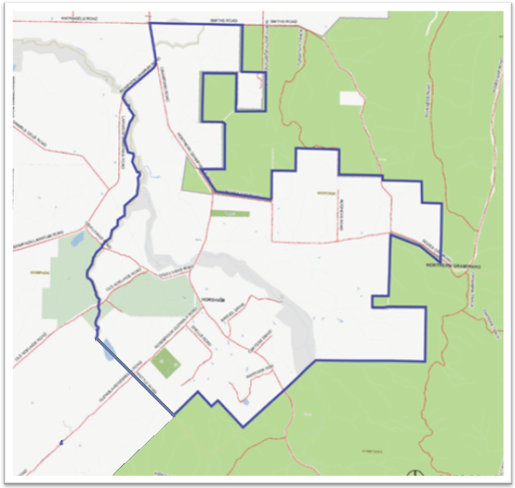
Horsham

Grampians National Park and Grampians Peaks Trail

Renowned for rugged mountain ranges, rich cultural heritage and breathtaking scenic views, the 168,000 hectare Grampians National Park (Gariwerd) is recognised as the single most important botanical reserve in Victoria. The Grampians National Park features 167 species of threatened flora, 26 of which are endemic to the park. A further 98 plant species are listed as threatened under State or Commonwealth legislation. The Park also supports a diverse community of fauna including the endangered red-tailed black cockatoo and smoky mouse.

In addition to being a valuable environmental resource, the Grampians National Park is Victoria’s third most visited park and one of Australia’s most important nature based and cultural tourism destinations. The tourist value of the Grampians National Park is expected to increase at the completion of the Grampians Peaks Trail.

The Grampians Peaks Trail will be a world-class, long distance walking experience, with a total length of 144,246m, with the full walk taking 12 nights. The first stage of the Trail was opened in May 2015. It is expected to be fully completed by 2025.

The Grampians Peaks Trail Masterplan envisages total overnight visitor numbers to the Grampians Peaks Trail reaching 53,241 by 2020 and 80,151 by 2025. Broad estimates of the Grampians Peaks Trail revenue per year vary from $2.55million in 2015 up to $6.39million in 2025 (upon completion of the trail).

The Grampians Peaks Trail Masterplan recognises the importance of off-park accommodation on private land to add to the experience for walkers. There is also opportunity for off-walk tourism opportunities which can add to the overall experience. Wartook Valley is well placed to take advantage of these opportunities. This is particularly the case for the eastern most portion of the Wartook Valley which is located within close proximity to the Pohlner site identified as a potential Grampians Peak Trail Lodge Setting.

The Wartook to Zumsteins Cycling/Walking Trail is another opportunity for the Wartook Valley to connect with the Grampians National Park and a secondary entry point onto the Grampians Peaks Trail. Planning for the Cycling/Walking Trail is still underway, and at the time of writing the alignment of the trail has not yet been confirmed. The Wartook Valley Strategy recognises the potential benefit of the cycling/walking trail for residents and visitors by providing additional connections into Zumsteins and the Grampians National Park and Grampians Peaks Trail.

1.7 Planning Background
Various planning studies which included land within the Wartook Valley have occurred in the past. These include the Grampians Surrounds Strategy Discussion Paper 1991, the Wartook/Grampians Area Planning Study 1994 and more recently the Rural Zones Review 2010.
The Wartook/Grampians Area Planning Study identified that the Grampian’s National Park is the dominant attraction for the locality and all development must continue to be subservient to this outstanding natural and national asset and that if the icon is visually impaired by development throughout its approaches, the future economic and social wellbeing of the Wartook area was unlikely to be improved or sustained. The Study also identified that small scale tourism accommodation and attractions were largely supported by owners/occupiers of the area, provided they protected the environment and were able to be sufficiently serviced. It appears that the changes to the planning controls recommended under this study were never implemented, likely due to the local government amalgamations and introduction of New Format Planning Schemes.
As part of the New Format Planning Scheme rollout, the existing planning controls were translated into the new zones and overlays. The planning controls which were generally applied to the Wartook Valley area at that time were as follows:

- Rural Zone (generally applied to private land)
- Public Conservation Zone (generally applied to public land)
- Environmental Significance Overlay 1 - Wartook Tourist Area
- Environmental Significance Overlay 4 - Water Catchment Protection
- Environmental Significance Overlay 5 - Channel and Reservoir Protection (applied to relevant land)
- Significant Landscape Overlay 1 – Grampians National Park

The controls as originally translated continue to apply today, apart from the notable change to the Rural Zone. In 2007, the Rural Zone was amended by the State Government and transformed into the Farming Zone. The change from the Rural Zone to the Farming Zone affected tourism uses, with many tourism associated uses, which were as-of-right or permissible with a permit, becoming discouraged or prohibited.

More recently, the Horsham Rural Zones Review 2010 evaluated the rural planning controls within Horsham Rural City Council.

The Review identified conflict between the purpose and objectives of the Farming Zone, the desire for small scale tourism development, and the Laharum Wartook Community Action Plan. The Laharum Wartook Community Action Plan acknowledged that the Wartook Valley was the subject of some conflict regarding how land in the area should be and is used.

This conflict is reflected in the planning controls for the area which see a range of overlay controls applied for the protection of the environment, a Local Planning Policy that encourages the development of sustainable tourism operations in the area, and the application of the Farming Zone which seeks the protection of land for agriculture. Despite acknowledging further work is required, the Horsham Rural Zones Review made some recommendations for the Wartook Valley, which are summarised below:

- Undertake strategic investigation into expectations for Wartook Valley and provide policy direction regarding the future use and development of the area.
- Provide greater policy direction for tourism and rural activity development in the planning scheme.
- Draw a settlement boundary around existing development within Wartook.
- Undertake a rezoning of small land parcels along Rose Gap and Smiths Road to the Rural Conservation Zone in line with the location of Trust for Nature Covenants, environmental values and limited capacity for agriculture and investigate other areas where this may be appropriate.
- Generally retain the Farming Zone in the area to protect agricultural land and to provide buffers to the national park.
- Review the Farming Zone and Environmental Significance Overlay Schedule 1 for the Wartook valley pending completion of strategic work on the future direction for this region as the most effective means of protecting the national park.
- Provide greater policy direction for tourism and rural activity development in the planning scheme.
- Undertake development of a strategy for the area in consultation with authorities and the local community and consider the application of the rural zones.

The Horsham Rural Zones Review was a key catalyst for this project. The Study Area for the Wartook Valley Strategy is derived from point 6, above, and uses the extent of Environmental Significance Overlay Schedule 1 Wartook Tourist Area to define the Study Area for the project. Some minor changes to the Study Area were considered during the early stages of the project to correct mapping anomalies with Planning Scheme map No.30.

1.8 Summary of Key Issues
The following is a summary of key issues identified through the Background Paper and clarified through Working Group Process. The Wartook Valley Strategy provides guidance on these issues.

- The current Horsham Planning Scheme controls do not provide clear guidance and vision for what is considered appropriate development and use within the Wartook Valley.

- The area contains high ecological values, with a diverse range of ecological vegetation classes and habitat of some listed flora and fauna.

- The area contains high Landscape Values, not only in relation to the national and state parks, but of local open agricultural and forested areas.

- Sensitive uses and land include the adjacent Grampians National Park and Wartook State Forest, as well as other nearby national and state parks and the water catchment areas.

- There are numerous significant views within and across the area.

- There is opportunity for additional tourism businesses, including food retailing, farm gate produce, nature-based tourism. The tourism industry would benefit from a ‘catalyst’ investment.

- There is demand for rural lifestyle lots within the Wartook Valley, with the lots which have access to infrastructure such as mobile phone coverage and water being more attractive to purchasers.

- Smaller rural lifestyle lots pose changes to the character and use of the area, as such controls relating to minimum lot sizes are important.

- The Grampians Peak Trail is a key project which is likely to have an impact on the Wartook Valley.

Part 2: The Strategy

2.1 Vision
“Nestled at the western base of the Grampians National Park, the Wartook Valley will continue to provide some of Victoria’s most spectacular, yet unheralded natural landscapes. Due to the environmental custodianship actions of past, present, and future landowners, the Wartook Valley contains spectacular environmental values, which enhance the overall value and experience of “The Valley”. In future, the Wartook Valley will continue to represent the very best of the region, becoming a preferred tourism destination or lifestyle choice for people seeking natural beauty, wildlife, outdoor recreation and local primary production opportunities within a tranquil atmosphere and with easy access to the Grampians National Park and the Grampians Peaks trail.”

2.2 Principles

- Guide future development and management of the Wartook Valley in a sustainable manner.
- Provide clear direction to manage future growth, investment, opportunity and change.
- Identify opportunities for sustainable economic growth, recreation and tourism.
- Preserve and enhance the setting of the Wartook Valley for community and visitors alike.
- Define the high environmental, landscape, and cultural values present within the Wartook Valley which require specific protection.

2.3 Settlement and Housing
2.3.1 Context

The Wartook Valley comprises land traditionally used for grazing. While grazing still exists, predominately on the western side of Northern Grampians Road, some land has been subdivided into smaller lots and is now used for other purposes. As a result a significant share of the Study Area has been allowed to revegetate.

The dominant uses of the land are for small scale accommodation uses, and rural lifestyle and agricultural purposes.
- The majority of lots (42%) are between 16 ha and 40 ha in size. Most of these lots are located on Northern Grampians Road, and around Snells Road and are used for a mix of purposes including small-scale B&B/Lodge style accommodation, and rural lifestyle living.
- 35 lots, or 26% of all lots in the Study Area, are larger than 40 ha in size and are used exclusively for traditional agricultural purposes (sheep grazing).
- Lots between 8ha and 16ha in size comprise 17% of total lots, and are primarily located on Roses Gap Road and Samuels Drive. Again, these lots are predominantly for rural lifestyle living purposes.
- The remaining lots, (21 lots or 15% of total lots, are less than 8ha in size. The majority of these lots are located on Roses Gap Road, and are effectively used for rural lifestyle living purposes.

The Wartook Valley resident population was estimated at 320 persons in 2013, increasing from approximately 270 persons in 2001, at an average rate of +1.4% pa over the period (or +50 persons over the 12-year period). This overall rate of growth has outpaced the rate of growth observed for Horsham and regional Victoria over the period, and highlights the attractiveness of the Wartook Valley as a place to live.

Wartook Valley’s attractive rural amenity (including its proximity to the Grampians National Park), and access to all major facilities and services in Horsham has meant the area has become a popular place for rural lifestyle living. Rural lifestyle living has occurred predominantly on 16ha lots in and around the southern parts of Northern Grampians Road, Snells Road, as well as Roses Gap Road. Roses Gap Road also contains smaller lots (4ha to 8ha).

While official State population forecasts at a small area level are not available, the Wartook Valley, given its proximity and accessibility to Horsham and attractive locational attributes, is expected to grow.

Figure 2 Wartook Valley Land Supply by Lots Size
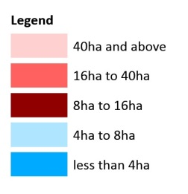
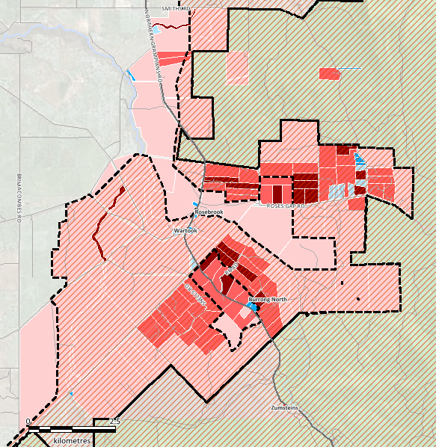
Produced by Essential Economics with MapInfo, StreetPro and Vicmap Data
The settlement character of Wartook Valley is generally dispersed, with some parts having more concentrated development with smaller allotments. Much of the Wartook Valley is already used for rural lifestyle lots, and it is considered that many of these lots contribute to the rural and pleasant character.

Decisions on future subdivision and development should be made in the context of the environment and Landscape Values of the area. Subdivision that allows the creation of lots at ever decreasing size, combined with development contemplated by that subdivision, may result in development that upsets and detracts from the areas character, landscape and environmental values. Zoning controls will identify areas where additional subdivision and development are discouraged, responding to the conservation, environment and Landscape Values, environmental risk and protection of agricultural land. Zones will also identify areas where more active uses are possible, having regard to protecting the rural amenity and environmental and Landscape Values. Overlay controls such as the Significant Landscape Overlay and Environmental Significance Overlay will provide guidance on how subdivision and development should respond to the specific environmental and Landscape Values within the Wartook Valley.

Fire and Flood Risk

The Wartook Valley region is broadly recognised as being at risk of fire. The Wartook Valley is a designated Bushfire Prone Area under the Victorian Building Act. The Horsham Rural City Council Municipal Fire Management Plan 2012-2015 identifies the Wartook Valley as having very high fire risk, with the threat of grassfire and bushfire. Parts of the land within the Study Area are mapped on the Victorian Fire Risk register. The Bushfire Management Overlay currently applies to much of the Study Area.

Risk of fire is to be considered holistically and managed on a case by case basis to ensure the best and most practical outcomes are achieved to balance the risks associated with living, working and visiting the Wartook Valley.

While not currently recognised through the Horsham Planning Scheme, some of the Wartook Valley is subject to flooding. A flood investigation of the Wartook Valley is being undertaken to better understand, and plan for, flooding within the Study Area. Until that study is completed, new uses, subdivision and development within areas with a history of flooding and inundation should consider potential impacts with input from Council and the Wimmera Catchment Management Authority.

Subdivision

Subdivision is the process of creating individual titles for land parcels, units, apartments, shops and commercial and industrial buildings to enable their separate sale.

All land, regardless of its location, may be subdivided. Victorian Planning Law determines the size of lot that land can be subdivided into. The law does this by allocating all land into a zone. Different zones have different subdivision standards. In the Wartook Valley Strategy Study Area, the current minimum lot size for land is 16 hectares. This means that in order for land to be subdivided, it must be at least 32 hectares to be allowed to be subdivided into two lots.

Historically, there are a number of lots in the Wartook Valley Strategy Study Area which have been subdivided into lots less than 16 hectares. These lots were created prior to the introduction of the 16 hectare minimum lot size. These smaller lots cannot be further subdivided due to their size.

Part 3 Implementation of this strategy provides further information on existing and proposed lot size minimums. It should be noted that the Wartook Valley Strategy does not recommend the reduction of existing lot size minimums.

    - Objectives

O1 To encourage a mix of accommodation options and visitor experiences.
O2 To enable a variety of land uses, including agriculture, rural living, tourism, and recreation.
O3 To identify preferred areas for development and subdivision.
O4 To identify areas where additional development and subdivision are not encouraged.
O5 To encourage appropriate siting and design of new subdivision and development, having regard to landscape and environmental values, views and vistas, major tourist routes and facilities, and natural disaster and environmental risks (including fire/flood/access).

    - Strategies

S1 Encourage rural living / lifestyle development in defined locations where constraints can be addressed and managed.
S2 Discourage rural living / lifestyle development on land which is constrained.
S3 Specify design guidelines which can be used to assist in the preparation and assessment of planning applications.
S4 Ensure that new development provides infrastructure services to meet its needs.
S5 Ensure that new development does not disrupt or restrict existing or future viable agricultural activities.
S6 Require the preparation of a site context description and design response for all new development which addresses: landscape, views & vistas, fire risk, flooding, design, siting, waterways and drainage lines, access, waste, and environment.
S7 Encourage uses along main transport corridors which enhance the overall appreciation of the landscape qualities (such as cut flower productions and farm gate sales in complementary buildings).
S8 Avoid ribbon development and encourage new subdivision to utilise existing vehicle access points off roads.

2.4 Environment
    - Context

The spectacular environmental values of the Wartook Valley largely stem from its location adjacent to the Grampians National Park.

The Grampians Peaks Trail Master Plan identifies the Grampians National Park (Geriward) as the fourth largest and one of the highest profile parks in Victoria. It is a core area for biodiversity and is recognised as the single most important botanical reserve in Victoria.

Described as a “natural amphitheatre”, the land of the Wartook Valley slopes down from the dramatic peaks of the Grampians to become relatively flat throughout the remainder of the Study Area. River systems include McKenzie River, Boggy Creek, Chinaman Creek, Mount Zero Channel and various other small water systems.

The Wartook Valley contains hundreds of native species of flora and fauna, many of which are classified on the Victorian Advisory list as Threatened, Vulnerable or Endangered and listed on the Flora and Fauna Guarantee Act 1998. The subject land also includes Ecological Vegetation Classes with a bioregional conservation status of depleted, vulnerable and endangered. Generally the more sensitive Ecological Vegetation Classes are located along and to the south of the Mackenzie River. Clause 52.17 Native Vegetation will continue to apply to the Study Area.

Pest plants and animals are also present. These pose a threat to the native flora and fauna, particularly given the subject land’s location in relation to the Grampians National Park. Furthermore, previous studies within the Horsham Rural City Council have identified that Parks Victoria wish to achieve buffers between park boundaries and adjoining land uses in order to protect vegetation and biodiversity, as well as achieving a fire buffer, prevent pest infestations and minimise the impacts of dwellings and intensive agriculture.

As identified by the existing Environmental Significance Overlay 4 the whole of the subject land is identified as being part of the Wimmera Systems Declared Water Supply Catchment area (listed within the Catchment and Land Protection Act 1994). The protection of this water supply catchment is controlled by the Environmental Significance Overlay Schedule 4.

Bushfire Management Overlay currently applies to much of the Study Area, identifying that the area is subject to fire risk. While only a small portion of the Study Area is identified as being within the Land Subject to Inundation Overlay, the area is known to be affected by flood. Refer above for further information on the fire and flood risk.

Part of the land is identified as being an area of Aboriginal Cultural Heritage Sensitivity. This is generally land adjacent a named waterway, such as McKenzie River and Boggy Creek. Any planning applications within land identified as being sensitive would need to demonstrate compliance with the Aboriginal Heritage Act 2006.

Trust for Nature Covenants
A covenant is a private treaty registered on a land title by the owner of the land. A restrictive covenant is a private written agreement which restricts, or otherwise controls the use or development of the land described on the title of the affected property. A Trust for Nature Covenant is one type of restrictive covenant.

Restrictive covenants have no effect on land where the covenant is not registered on the land title.

A covenant is not enforced by either government or Council.

Enforcement of the conditions of a covenant, or action for breach of a covenant must be taken by a beneficiary to the covenant through the Courts. Horsham Rural City Council has no role in taking action to enforce compliance with a restrictive covenant.

Council must refuse the granting of a permit that would authorise anything that would be a breach of a registered restrictive covenant.

With the approval of the Minister, a Trust for Nature covenant may be released by the Trust or varied by an agreement between the Trust and all persons having an interest in the land burdened by the covenant who are bound by the covenant. Where the owner of any land who first enters into a covenant with the Trust is unable to reach agreement with the Trust regarding the release of such covenant, the matter shall be determined by the Governor in Council whose decision shall be final.

Trust for Nature has developed a conservation covenant program. A conservation covenant is a voluntary, legal agreement made between a private landowner and Trust for Nature through the Conservation Covenant Program. Its purpose is to permanently conserve and protect the natural, cultural or scientific values of the land. At the time of writing, there are nineteen conservation covenants in the Study Area. The number of properties in the study area that have Trust for Nature Covenants registered on title may result in significant impacts to the environment and landscape values of the area, and as such, should be addressed by this strategy.

While the specific nature of each covenant is individually negotiated, a standard conservation covenant generally prohibits:

- native vegetation removal | - removal of wood or timber
- introduction of any non-indigenous vegetation | - introduction of any non-indigenous fauna i.e. pets
- subdivision | - pasture establishment
- grazing by livestock | - the application of fertiliser
- deterioration in the quality, flow or quantity of water | - removal or disturbance of soil or rocks, including cultivation
- recreational use of trail bikes and other recreational vehicles

Restrictions enacted by a covenant operate independently from local Councils, and may also contradict various requirements of the Planning Scheme. Given that the application of restrictive covenants in the study area is not consistent, and the majority of land in the study area does not have restrictive covenants registered on title, these forms of land use controls cannot be relied on for implementation of the Wartook Valley Strategy as land use and development conflicts may arise from this uncoordinated approach.

    - Objectives

O6 To protect areas of environmental, cultural and agricultural significance.
O7 To identify and enhance the natural environment including waterways, wildlife corridors and habitat, native vegetation and old and major strands of trees.
O8 To ensure new development is commensurate with environmental risk.
O9 To recognise the rich indigenous and post-contact culture of the Wartook Valley.
O10 To encourage new development that:
  - Improves the state of the natural environment;
  - Uses materials/design that compliments and nestles into the local area;
  - Overcomes/repairs previous land management practices and other impacts on the environment.
    - Strategies

S9 Identify and protect areas containing significant flora and fauna, in particular the listed threatened and rare species which exist within the area.
S10 Value the long history of indigenous culture and encourage planning applications for new uses and development to recognise and respond to indigenous and post contact culture as appropriate within its context.
S11 Identify and protect high quality agricultural land.
S12 Require new development to demonstrate impact on environmental assets, including land and water resources.
S13 Provide guidelines for new development with regard to:
  - Landscape plans (species selection).
  - Land Management - regrowth, fire risk, invasive pest species.
  - Biolink planting.
S14 Require new development to be supported by a Land Management Plan which includes consideration of remnant vegetation, wildlife, water resources, erosion, control and reversal of salinity, noxious and environmental weeds, managing land to class and soil, as relevant to the subject land.
S15 Periodically review the application of the Bushfire Management Overlay to keep account of properties undergoing revegetation.

2.5 Landscape
    - Context

The Grampians, of which the Wartook Valley is a part of, is considered to be a dramatic and visually spectacular landscape that dominates the surrounding flat pastoral plains.

The South West Victoria Landscape Assessment Study 2013 (Department of Planning and Community Development) identifies the Wartook Valley as having an exceptional (State) level of significance. The work undertaken as part of the Landscape Assessment Studies by the former Department of Planning and Community Development has been expanded on as part of this project.

It is considered that the visual sensitivity of the valley is high, and any significant changes in the current landscape amenity and uses will affect the appreciation and experience of the area.

The associated plan (below) shows that open pastoral land (with scattered trees) dominate the low lying valley floor, and the slopes of the adjoining hills and mountains are characterised by forested area. The McKenzie River and Wartook State Forest are treed areas cutting across the lowland open pastoral farmland. This development pattern, relating to the underling natural systems, provides a high degree of coherence.

The Valley and the surrounding Grampians landscapes (bush clad slopes, rocky escarpments, and jagged skyline peaks) are viewed and appreciated from a variety of viewpoints:
- The North Grampians Road.
- Roses Gap Road.
- Rosebrook Glenisla Road.
- Secondary local roads off the main through roads.
- Private residential houses and guest houses on slopes overlooking the Valley.
In addition, views into the Valley are obtained from the surrounding peaks of the adjoining Grampians, and this will be further reinforced by the development of the Grampians Peak Trail in the years ahead.

Localised topography also has a significant influence on the viewing experience of the Valley and the Grampians. For example:

- In the southern area of the Valley, when travelling along the North Grampians Road, views are ‘forced’ towards the north and east across the valley and to the distant Grampian peaks as a result of the road alignment and being sited mid-slope.
- When travelling along Roses Gap Road, there are framed views from the crest (near the main North Grampians Road) in both directions:
- towards the vast flat plains to the west, and
- towards the Grampian peaks
An understanding and appreciation of these significant viewing points and corridors in the area, along with the implementation of good design, will ensure the inherent Landscape Values and amenity of the Valley will be protected for residents, visitors, and future generations.

Design Guidelines included in Part 3 use the existing landscape amenity and values, developed during the consultation and assessment process, underpin direction for good design of existing and new developments and subdivisions. Aspects such as the siting and orientation of dwellings and buildings in the landscape, built form that is integrated with the topography and local environment, along with vegetation planting that enhances and screens views will all go towards ensuring the attractive landscape of the Valley will continue to be enjoyed and appreciated by all who experience it.

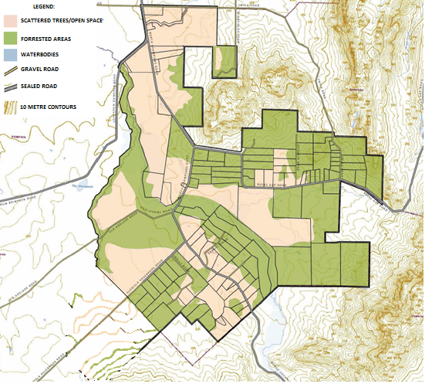

    - Objectives
O11 To recognise the significance of the Landscape Values of the Wartook Valley and its surrounds, including the Grampians National Park.
O12 To ensure new development occurs where significant landscapes can be protected.
O13 To encourage land uses, development and subdivision that maintain and enhance identified landscapes values.
O14 Protect significant views and vistas.

    - Strategies
S16 Ensure that Landscape Values are considered in the assessment of applications for both new buildings and subdivision.
S17 Introduce design standards to ensure new development responds to identified Landscape Values and protects valuable views and vistas.
S18 Ensure new development is sited in locations of low visual impact from key viewing points.
S19 Avoid breaching ridgelines or hilltops.
S20 Require buildings and structures to be constructed of materials and colours which minimise visual intrusion to the landscape. Colours used should be similar to that found in the natural environment within the immediate area.
S21 Avoid the use of reflective surfaces to minimise glare and visual impact of development.

2.6 Economics and Tourism
    - Context

The land within the Wartook Valley was traditionally used for grazing, however this has changed over time. The smaller lots which exist within the Wartook Valley are most suitable to rural lifestyle lots, with the medium and larger lots being able to sustain niche, specialised or more traditional agriculture activities.

Analysis of the Australian Bureau of Statistics Census data for 2006 and 2011 provides an indication of labour force trends in the Wartook Valley region. As ‘place of work’ data is not available for the Wartook Valley, labour force data has been used a proxy for jobs in the general area. It is important to note that a share of Wartook Valley residents travel to other locations (including Horsham) for work, and it is possible that non-residents work in the Wartook Valley.

A summary of labour force trends most relevant to future opportunities in the Study Area are described below:
- Agriculture is the largest employing industry in the region and accounts for 34% of the resident labour force, but this share has declined from 50% of total employment since 2006.
- Manufacturing has declined from 8% total employment in 2006 to 4% in 2011.
- Retail Trade and Accommodation and food Services has increased from less than 1% of total employment in 2006 to 8% in 2011.
- Other major employing industries account for 22% of employment. These industries include service-related industries such as health care and social assistance; public administration and safety, and education and training. The majority of these jobs are located in Horsham, with Wartook Valley residents commuting to and from Horsham to access these jobs.

Given Wartook Valley’s proximity to the Grampians National Park, its environmental values and picturesque setting, tourism also forms another local industry, and there are numerous tourism based businesses within the Study Area.

The Grampians National Park is one of Victoria’s main tourist attractions, and as such the principal attraction within the region. The Grampians has a strong appeal for nature and culture based visitors, with activities ranging from scenic drives, bushwalking, rock climbing, cycling, camping, and picnics/BBQs, to nature appreciation and sightseeing, fishing and horseback riding.

While the attraction of the Grampians is well understood, estimates of the numbers of visitors to the national park vary widely. Previous work undertaken by the consultant (Grampians Peaks Trail – Economic Input into Masterplan) estimates approximately 170,000 overnight visitors in 2012 (including 95,000 persons staying in commercial accommodation and 75,000 staying in campsites), plus a further 260,000 day visitors.

The Central Area (Halls Gap and surrounds) accounts for an estimated 85% of total overnight visitors to the Grampians, while a smaller share of 11% is estimated for the Southern Area, and 4% for the Northern Area (where the Wartook Valley is located).

The economic contribution of tourism in the Wartook Valley is difficult to measure, however analysis prepared by REMPLAN for Horsham Rural City Council estimates that in 2013/14 approximately 5,030 persons were directly employed in tourism in the Grampians Region, representing 6.5% of total employment. In terms of output, tourism accounted for $814 million in 2013/14, or 4% of total output for all industries in the wider region.

As such it can be seen that the Wartook Valley absorbs a small amount of the total overnight visitors visiting the Grampians.

A number of projects that identify, map and generate new opportunities for tourism investment in the Wartook Valley and wider Grampians region are currently proposed.
These projects include:
- Wartook to Zumsteins Cycling/Walking Trail – a proposed trail linking Zumsteins recreation area and the existing Mackenzie Creek walking and bike trail to the Wartook Valley.
- Grampians Peaks Trail – a world class, long distance walking experience, showcasing the beauty and majesty of the Grampian’s natural and cultural landscapes. A Masterplan has been completed, and works have commenced, with Stage 1 opening on 29 May 2015, and the remaining stages expecting to be opened by 2019. The Grampians Peak Trail project, once completed, is projected to generate 80,000 new visitor nights by 2025.
- Grampians Way – a proposed ring road approximately 285km in length circling the Grampians National Park using the existing road network, which has been identified as a means of increasing tourism to the region including attracting the touring visitor segment.
- Ongoing Promotion – State Government funding secured to produce a promotional guide and organise a tourism event showcasing the Wartook Valley region.

The Grampians Peaks Trail Master Plan notes that the popularity of the Grampians has resulted in the development of a number of tourist facilities adjacent to the park and that these developments can complement the park experience and augment park management if they are planned properly and in consultation with Parks Victoria.

Given the Wartook to Zumsteins Cycling/Walking Trail and the Grampians Peaks Trail, there are new opportunities for the tourism industry within the Wartook Valley. Direction should be provide to ensure future tourism development is consistent with the environmental and scenic values of the Wartook Valley and continue the niche of low key, retreat and nature type tourism experiences, while maximising the benefits additional tourism operations could bring. Other opportunities which would be consistent with this low key niche include greater development of farm gate produce.

The identified precincts (see section 2.9), are based on their Landscape Values, the Ecological Vegetation Classes of native vegetation present, and existing land use. The precincts provide guidance on how and where new tourism, and other new uses, can be considered to ensure they are in keeping with the established Vision and Principles that drive this Strategy. Guidance is provided within the Objectives and Strategies below.

    - Objectives

O15 To develop strategic linkages amongst tourism, recreation, agriculture and the natural environment.
O16 To capitalise on the regional position between Melbourne and Adelaide and proximity to the western base of the Grampians National Park.
O17 To facilitate development of a tourism service sector to support new businesses.
O18 To promote tourism ventures and activities adding value to the Wartook Valley experience.
O19 To discourage development that is inconsistent with the natural landscape experience.
O20 To promote a range of activities that add to the experience of the local area.

    - Strategies

S22 Encourage tourism, recreation, agriculture and rural living uses within the Study Area.
S23 Identify appropriate locations (with regard to environmental and Landscape Values) for:
  - Connection and stopping places on the Grampians Peak Trail and Wartook to Zumsteins walking and cycling trail.
  - Tourism / commercial uses.
  - Public infrastructure, amenities, and activities.
  - Directional signage.
  - Emergency management.
S24 Encourage tourism and recreation uses that may benefit from close proximity to the Wartook to Zumsteins walking and cycling trail and other walking trails.
S25 Encourage other appropriately located eco-tourism, recreation, agri-tourism and accommodation businesses outside of the central core where other objectives and strategies can be achieved.
S26 Encourage the ongoing role and enhancement of agriculture within the Study Area.
S27 Identify areas that can support additional development and activity without adversely impacting environmental and Landscape Values of the Wartook Valley.
S28 Avoid locating new uses or activities within the Wartook Valley that may compromise environmental and Landscape Values of the Wartook Valley.

2.7 Transport and Infrastructure
    - Context

The recently completed Wimmera Mallee pipeline replaced the old open channel system, which was estimated to lose up to 80% of water through evaporation and seepage. Supply System 6 generally services Wartook Valley, however some properties within the subject land are outside the serviceable area. The area is generally serviced with electricity from PowerCor, however some properties are outside the serviceable area.

Communication infrastructure is poor in the Wartook Valley. The Laharum Wartook Community Action Plan identified better and more reliable access to communications as a key priority, this is considered to be particularly important noting the area is listed as being of Very High Fire Risk.

There are numerous narrow, unsurfaced and private roads which provide access to properties within the area. Northern Grampians Road provides the main access through the area, connecting Wartook Valley to Horsham, the region’s largest city. Wartook Valley is a 3½ hour drive from Melbourne and Geelong and a 2½ hour drive from Ballarat. The Henty Highway (A200), Western Highway (A8) and Wimmera Highway (B240) provide linkages through to Wartook Valley.

Private car and organised coach trips provide access to Wartook Valley. Public Transport does not service the Study Area, however nearby Halls Gap and Horsham do connect with broader V-Line services. The nearby Grampians air strip, within the Assess Ears Wilderness Lodge, provides another avenue for accessing the Wartook Valley.

There is opportunity to support tourism within the Grampians National Park through privately run transport options for tourists which pick up and drop off bushwalkers and campers. Such services are to be negotiated with Parks Victoria.

The Wartook Valley benefits from multiple community groups within the Study Area and broader region, including sporting groups and facilities. The Laharum Public Hall to the north of the Study Area provides a public space to host further community groups should they be established, such as a Men’s Shed. The Laharum Kindergarten and Primary School provide local schooling for the area, with secondary schools being located in Horsham.

There is opportunity to better maintain existing and/or provide additional community and tourism infrastructure such as picnic facilities, walking/cycling routes, information signage and viewpoints. New community/tourism facilities should be connected with the Wartook to Zumsteins Cycling/Walking Trail.

    - Objectives

O21 To provide well connected and accessible transport and infrastructure.
O22 To provide well defined and logical connections to surrounding areas, including Grampians National Park, Horsham, and Halls Gap.
O23 To ensure new development and subdivision provides infrastructure and services to meet its needs.
O24 To encourage the provision of local community and tourist infrastructure.
O25 To ensure new infrastructure blends seamlessly with the natural assets of the area and does not detract from views.

    - Strategies

S29 Provide logical connections to nearby towns and places of interest.
S30 Support the connection to the Grampians Peak Trail and Wartook to Zumsteins walking and cycling trail to an appropriate location.
S31 Encourage the establishment of community facilities and infrastructure, such as community meeting spaces and the like.
S32 Ensure new infrastructure is of a standard suitable for emergency access/use.
S33 Encourage the provision of appropriately located picnic areas, toilets, bins, visitor information, tourist routes (walking, cycling and driving) and viewpoints, particularly to the north and western fringe of the Grampians National Park.
S34 Investigate the potential for a community transport service.
S35 Upgrade telecommunications facilities to meet the needs of residents, visitors and emergency services.
S36 Specify information requirements for new developments and subdivision in relation to availability of servicing, and if no servicing is available, that adequate servicing can be provided onsite.
S37 Consider impacts of new infrastructure on wildlife and habitat.
S38 Consider lowering vehicle speeds along Northern Grampians Road, in consultation with Vic Roads.

2.8 Sustainability
    - Context

The term ‘sustainability’ can mean a broad range of things. In this report we refer to sustainability in the same manner as the Horsham Rural City Council Environmental Sustainability StrategyStrategy 2010 which states:

Sustainability is about:
- doing more with less (resource efficiency);
- making sure we don’t leave the cupboard bare for the next generation (resource planning);
- thinking about what we leave behind (resource management)

Environmental sustainability is also about having a better understanding of environmental systems that support what we do, and the need to take a broader view to recognise that our day-to-day activities can simultaneously affect our economy, environment and community.

Sustainable principles can be present in behaviour, land management practices, land use and built form.

A key driver of adopting sustainable practices is to respond to climate change.

Climate change refers to the unnatural warming of the planet through human generated greenhouse gas emissions. The wellbeing of all Victorians is directly connected to the health of our environment, the quality of our infrastructure and services, and the strength of our economy. Changes in our climate may put each of these things under pressure.

Impacts of climate change to agricultural production is unknown, however there is a clear potential for resource management issues to occur, including potential for reduced productivity and agricultural viability. Given the significant role the agricultural industry plays within the broader Horsham region, climate change resilience is likely to become a growing consideration in the future.

Of particular concern to Wartook Valley is the potential for climate change to increase extreme weather patterns which in turn increase the length of the fire season and an increased number of extreme fire danger days. As outlined in the Climate Council’s report Be Prepared: Climate Change and the Victorian Bushfire Threat, the role of climate change in bushfires is both straightforward and complex, but essentially climate change is a factor at play in the ignition of a fire, fuelling of a fire and by providing weather conditions which are conductive to the fire spreading.

The Wartook Valley Strategy acknowledges the wide range of challenges associated with climate change, and promotes and supports actions and outcomes which result in more sustainable behaviour, land management practices, land use and built form.

    - Objectives

O26 To encourage sustainable land management practices within the Wartook Valley.
O27 To encourage Sustainable Building Design.
O28 To encourage sustainable land management practices that are responsive to the risk posed by extreme weather events including fire and flood.
O29 To improve community resilience to extreme weather events.
O30 To encourage best practice Water Sensitive Design.

    - Strategies

S39 Develop sustainable design guidelines for new development within Wartook Valley.
S40 Require new development to maintain the quality and quantity of water entering waterways.
S41 Encourage co-operative interaction between Parks Victoria and owners/occupiers of land adjoining the Grampians National Park.
S42 Encourage Environmentally Sustainable Design (ESD) measures to be integrated into new or retrofitted buildings. This could include: energy efficiency and solar design, water efficiency, waste management practices, and the use of sustainable materials.

2.9 Proposed Precincts
Applying the Vision, Principles, Objectives and Strategies developed in Part 2 of the Wartook Valley Strategy to the landscape assessment undertaken earlier in the project reveal how the different attributes of the land lend themselves to achieving different objectives. These different areas have been identified as precincts (Figure 4).

The precinct approach provides the ability to apply the various zones available from the Victorian Planning Provisions to different parts of the Study Area at a fine scale. The rationale for each of these precincts is contained in Table 3 on page 42. Table 3 also provides information on current zones and proposed zones and subdivision controls.

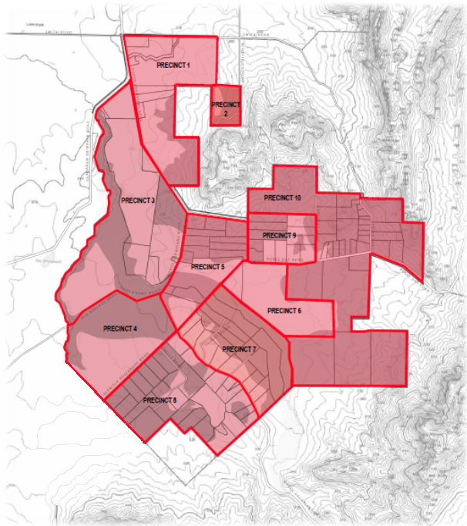

Figure 4: Proposed Precincts

2.10 Conclusion
The Wartook Valley Strategy was prepared by the Wartook Valley Working Group, which included two members representing local residents, two members representing businesses, two Horsham Rural City Council Councillors, Horsham Rural City Council staff and two external facilitators. Notes and outputs from each Working Group meeting were available on Council’s website, and consultation was conducted on the draft Vision, Principles, Themes, Objectives and Strategies.

The work undertaken on the project identified that the environmental and Landscape Values of the Wartook Valley were of critical importance. It is these elements which have driven the future vision and preferred outcomes which have been articulated within the Strategy. It was identified that the Grampians Peaks Trail and Wartook to Zumsteins Cycling/Walking Trail provide new opportunities to support existing business and leverage investment in new tourism business. The Wartook Valley Strategy seeks to support these new uses where they are consistent with the identified Environmental and Landscape Values. Furthermore, it was recognised that the area supported existing rural lifestyle opportunities, which are inconsistent with the purpose of the existing Farming Zone. The Wartook Valley Strategy provides an opportunity to formalise use of land for rural lifestyle, recognising the risks associated with flood but more specifically bushfire.

Part 3: Implementation

3.1 Implementation Plan

Review of Existing Planning Provisions
The work undertaken as part of the Wartook Valley Strategy has produced a vision for the Wartook Valley, as well as Principles, Objectives and Strategies which articulate how the vision is to be achieved. A key driver for this project was the acknowledgement that the existing planning framework for the Wartook Valley required review and updating (see Section 1.7 Planning Background). This implementation section of the Strategy reviews the existing Planning Scheme controls in light of the recommendations of the Strategy.

Following the preparation of the Wartook Valley Strategy, a review of the existing planning controls and their relationship to the Wartook Valley Strategy recommendations was undertaken. This was to establish if there is a need for the planning controls to change.

It should be noted that the assessment of controls in Table 1, below, considers only the zone and overlay controls. A more detailed assessment relating to the Local Planning Policy Framework is undertaken in section 3.2.1 and Table 2, below.

Table 1: Review of Existing Planning Scheme Controls
 | Existing: | Comments
 | Policy
1 | Municipal Strategic Statement  The existing Municipal Strategic Statement refers to the current planning controls within the Wartook Valley. These are not consistent with the Wartook Valley Strategy.  There is currently a Planning Scheme amendment underway to introduce a new Municipal Strategic Statement to the Horsham Planning Scheme.  Horsham Planning Scheme Amendment C75 includes a section on the Wartook Valley, proposed clause 21.06-7. This proposed Clause includes the objective “To establish a set of Planning Scheme controls that provide guidance and direction for the use of land, the protection of environmental and scenic values, and design and development standards to be achieved by all new development”.  At the time of preparing the Wartook Valley Strategy, amendment C75 had been reviewed by an independent panel, and had been forwarded to the Minister for Planning for approval. | The Municipal Strategic Statement requires changes to implement the recommendations of the Wartook Valley Strategy.  The proposed new Municipal Strategic Statement Clause 21.06-7 includes the rationale for undertaking the Wartook Valley Strategy. As the Wartook Valley Strategy is now complete, Clause 21.06-7 needs to be redrafted to recognise the completion of the Wartook Valley Strategy and to implement its recommendations.  Include clear direction that the Wartook Valley Strategy makes no change to Clause 52.17 Native Vegetation.  A Planning Scheme amendment will be required.
2 | Clause 22.05 Wartook Tourist Policy  This Policy should be redrafted to implement the findings of the Wartook Valley Strategy. | Clause 22.05 Wartook Tourist Area Policy requires redrafting.  This Clause needs to reflect the outcomes from the Wartook Valley Strategy, and include reference to the Design Guidelines and direction on how land should be maintained.  Take the elements of tourism development promotion out of the current Environmental Significance Overlay Schedule 1 and include the relevant parts that are consistent with the Wartook Valley Strategy into a redrafted Clause 22.05 Wartook Tourist Area Policy.  The redrafted Wartook Valley Tourist Area Policy is to provide additional guidance for subdivision to ensure that any future subdivision, inclusive of boundary realignments, does not result in an increase in lots fronting Northern Grampians Road. New Buildings shall be located to maximise the possible set back from Northern Grampians Road, with preference for building envelopes to be located in areas already clear of significant vegetation. Consideration will be given to slope angle of the subject land, and the ability to use the natural topography of the land to lessen the impact of new buildings on views from public areas.
 | Zones
3 | Farming Zone (generally applied to private land)  The purpose of the Farming Zone is to:  - provide for the use of land for agriculture.  - encourage the retention of productive agricultural land.  - ensure that non-agricultural uses, including dwellings, do not adversely affect the use of land for agriculture.  - encourage the retention of employment and population to support rural communities.  - encourage use and development of land based on comprehensive and sustainable land management practices and infrastructure provision. | Rezone identified land (see section 3.2.2, below) from the Farming Zone consistent with recommended zoning, as set out in section 3.2.2 of this document.  As much of the land within the Wartook Valley Strategy Study Area is not used for agricultural production, the Farming Zone does not promote the current and preferred future use of the land. The focus on agricultural uses, above all other uses, is inconsistent with the direction of the Strategy, which seeks to protect Environmental and Landscape Values and allow for some tourism uses.  A change of zone is required within some areas to achieve the Objectives of the Wartook Valley Strategy.  See Zoning application principles, in section 3.2.2 below.
4 | Public Conservation and Resource Zone (generally applied to public land)  The purpose of the Zone is to:  - protect and conserve the natural environment and natural processes for their historic, scientific, landscape, habitat or cultural values.  - provide facilities which assist in public education and interpretation of the natural environment with minimal degradation of the natural environment or natural processes.  - provide for appropriate resource based uses. | No Change is required to land currently within the Public Conservation and Resource Zone.  Consistent with the direction of Strategy.
5 | Road Zone Category 1 (applied to main road)  The purpose of the Zone is to:  - identify significant existing roads.  - identify land which has been acquired for a significant proposed road. | No Change is required to land within the Road Zone Category 1.  Consistent with the direction of Strategy.
 | Overlays
6 | Environmental Significance Overlay 1 - Wartook Tourist Area  Seeks to encourage the development tourism development which minimises the development impact upon the environment. | Environmental Significance Overlay Schedule 1 requires redrafting to implement the recommendations from the Wartook Valley Strategy.  The tourism focus of the Environmental Significance Overlay Schedule 1 is not appropriate within the Environmental Significance Overlay and can be better achieved through zoning and policy.  Remove the tourism oriented controls from Environmental Significance Overlay Schedule 1 and include them in a redrafted Clause 22.05 Wartook Tourist Area Policy, as identified in 2, above.  Redraft the Environmental Significance Overlay Schedule 1 to better articulate the environmental significance of the area, without confusion of tourism aspects.  Incorporate the content of ESO4 and ESO5 into a redrafted Environmental Significance Overlay Schedule 1.  Include a statement as to the nature and significance of vegetation to be protected and a vegetation protection objective to be achieved as part of the redrafted ESO1 to afford greater protection of native vegetation.
7 | Environmental Significance Overlay 4 - Water Catchment Protection  Seeks to protect and maintain the water quality and yield within the Wimmera Systems Proclaimed Catchment. | Incorporate the content of Environmental Significance Overlay Schedule 4 into the redrafted Environmental Significance Overlay Schedule 1 for the area covered by the Wartook Valley Strategy.  Incorporate into Environmental Significance Overlay Schedule 1, see above.
8 | Environmental Significance Overlay 5 - Channel and Reservoir Protection (applied to relevant land)  Seeks to maintain and enhance the quality and supply of irrigation and domestic water throughout the Wimmera region, and protect water reservoirs and channels from pollution. | Incorporate the content of Environmental Significance Overlay Schedule 5 into the redrafted Environmental Significance Overlay Schedule 1  Incorporate into Environmental Significance Overlay Schedule 1, see above.
9 | Significant Landscape Overlay 1 – Grampians National Park  Seeks to conserve and enhance significance landscapes. | Create a new Significant Landscape Overlay to better articulate the Landscape Values, provide clearer direction for new development and acknowledge that the Landscape Values stem not solely from the Grampians National Park, but exist within the subject area, as articulated through the Wartook Valley Strategy.
10 | Land Subject to Inundation Overlay  Seeks to identify and respond to land within flood storage or flood fringe area. | No Change to the Planning Scheme is required at present.  The Wimmera Catchment Management Authority has initiated a flood study which will include the subject area. Any changes to the flood controls applicable in the Study Area will occur after the flood investigation has concluded.
11 | Bushfire Management Overlay  Seeks to identify bushfire hazard areas and ensure that development of land prioritises the protection of human life and strengthens community. | No Change is required to the Bushfire Management Overlay.  It is understood that the Bushfire Management Overlay has been reviewed by the Department of Environment Land Water and Planning, and will be updated via a separate Planning Scheme amendment process.

Implementation
The work above identifies that there is a need to update some of the Horsham Planning Scheme to implement the recommendations of the Wartook Valley Strategy. To achieve the recommendations of the Strategy it has been determined that it is appropriate to replace the existing Farming Zone with the full suite of Rural Zones. Land currently zoned Public Conservation and Resource Zone is not recommended for change as identified above.

Local Planning Policy Framework

It is recommended that updates are made to the Local Policy Framework to reflect the Wartook Valley Strategy.
Table 2: Recommended Changes to Local Planning Policy Framework
 | Wartook Valley Strategy | Consideration | Action
12 | Vision and Principles | Policy:  The Vision and Principles are best expressed through policy. | - Include the Vision and Principles from the Wartook Valley within the Local Planning Policy Framework of the Horsham Planning Scheme.
13 | Settlement and Housing | Zones:  Much of the land within the Study Area is already used for rural lifestyle lots, within the Farming Zone.  The Rural Living Zone is the most appropriate zone when considering rural living and low scale tourist accommodation. New zoning should consider existing lot sizes, and existing use. | - Apply Rural Living Zone to land where lot sizes are smaller, where land is not significantly constrained by environmental values and where the landscape is able to accommodate this type of land use and development as determined under the Landscape assessment below. Refer to section 3.2.2 of this report for more detail.  - No change in existing minimum subdivision size (remain at 16ha).
 |  | Overlays:  The risk of bushfire and flood are acknowledged.  There is no proposed changed to the Bushfire Management Overlay. Policy should provide additional guidance on these risks. | - No change to Bushfire Management Overlay  - Flood Investigation of the McKenzie River to be undertaken by Wimmera Catchment Management Authority.
 |  | Policy:  Policy should assist in outlining the preferred design outcomes, both in terms of subdivision and development. | - Update the Municipal Strategic Statement and Local Planning Policies of the Horsham Planning Scheme to include the Objectives and Strategies set out in the Wartook Valley Strategy.
14 | Environment | Zones:  It is considered that all of the identified zoning options provide scope to protect the environmental values of the land. | - Apply Rural Conservation Zone to identified land which: -  - is heavily vegetated,  - has areas with sensitive Ecological Vegetation Classes, and  - has been identified within the Landscape Assessment Report (refer Background Report) as having vegetation which contributes to the Landscape Values.  - Land not included within the Rural Conservation Zone is still expected to respond to the environmental values of the land. This is to be reflected within the new Environmental Significance Overlay, see below at 15.
 |  | Overlays:  Consider the tools available to consider the environmental value and significance of the land for all new developments and subdivision. A holistic approach to the environmental values should be taken and the whole of the Study Area should be included. | - Apply a new Environmental Significance Overlay.  - The new Environmental Significance Overlay should incorporate all elements of the environmental values of the area, including native vegetation, areas of habitat, located adjacent to the Grampians National Park, water quality and yield from the Wimmera Systems Proclaimed Catchment, and water quality of the Mackenzie creek.
 |  | Policy: Policy should assist in outlining the preferred design outcomes, both in terms of subdivision and development. | - Update Municipal Strategic Statement and Local Planning Policies to identify Objectives and Strategies contained in the Wartook Valley Strategy.  Clause 22.05 Wartook Tourist Area Policy in the Horsham Planning Scheme should be redrafted to specifically include under ‘Application Requirements’ the need to submit a Land Management Plan for any new land use or subdivision planning application and for new development unless advised by the responsible authority for planning (usually that is Horsham Rural City Council) that the Land Management Plan is not required. The redrafted policy should also call up the proposed Design Guidelines.
15 | Landscape  _______________________________  Incorporated Document | Zones:  Consider how the character of uses and density of development impacts on land and the ability to control and influence this through zoning. | - Apply the Farming Zone where agricultural land contributes to the valued landscape.  - Apply Rural Living or Rural Activity Zone where landscape can accommodate or benefit from, more diversity of land uses.
 |  | Overlays:  Considerer tools which provide opportunity to guide preferred development and subdivision outcomes.  Overlays should refer back to Design Guidelines. | - Apply a new Significant Landscape Overlay to the whole of the Study Area.  - The new Significant Landscape Overlay is to be based on the identified Landscape Values.  - The Significant Landscape Overlay is to cross reference the Design Guidelines that form part of the Wartook Valley Strategy. The Design Guidelines will be included as an Incorporated Document in the Horsham Planning Scheme, giving them statutory weight.
 |  | Policy: Policy should assist in outlining the preferred design outcomes, both in terms of subdivision and development. | - Update the Municipal Strategic Statement and Local Planning Policies to identify Objectives and Strategies set out in the Wartook Valley Strategy.
16 |  |  | - The Design Guidelines are to be incorporated into the Horsham Planning Scheme as an Incorporated Document, giving them statutory weight.
17 | Economics and Tourism | Zones:  Consideration of zones which will allow appropriate tourism or “farm gate” style uses (generally low scale and consistent with the Environmental and Landscape Values) where not conflicting with Environmental and Landscape Values. | - Retain the Farming Zone on large lots, lots with identified High Agricultural Class and where agriculture is the preferred use under the Landscape Values.  - Apply the Rural Activity Zone where a diverse range of uses can be accommodated as identified through the Landscape Values and where there are not significant environmental considerations which may limit the variety of uses.  - Schedules to the Rural Activity Zone to be utilised to clearly articulate purpose of zone and preferred outcomes.
Overlays:
N/A

 |  | Policy:  Policy should assist in outlining the preferred design outcomes, both in terms of subdivision and development. | - Update the Municipal Strategic Statement and Local Planning Policies to identify Objectives and Strategies set out in the Wartook Valley Strategy.
18 | Transport and Infrastructure | Zones:  N/A | N/A
 |  | Overlays:  N/A | N/A
 |  | Policy:  Policy should assist in outlining the preferred design outcomes, both in terms of subdivision and development. | - Update the Municipal Strategic Statement and Local Planning Policies to identify Objectives and Strategies set out in the Wartook Valley .
19 | Sustainability | Zones:  N/A | N/A
 |  | Overlays:  N/A | N/A
 |  | Policy:  Policy should assist in outlining the preferred design outcomes, both in terms of subdivision and development. | - Update Municipal Strategic Statement and Local Planning Policies to identify Objectives and Strategies set out in the Wartook Valley Strategy.  - Redraft clause 22.05 of the Wartook Tourist Area policy and the Environmental Significance Overlay to call up the Design Guidelines.  - Clause 22.05 of the Wartook Tourist Area Policy should specifically include under ‘Application Requirements’ the need to submit a Land Management Plan for any new land use or subdivision planning application and for new development unless advised by the responsible authority for planning (usually the Horsham Rural City Council) that the Land Management Plan is not required.
 |  | Incorporated Document: | - Design Guidelines should be incorporated into the Planning Scheme as an Incorporated Document giving them statutory weight.

Recommended Zoning
The Wartook Valley Strategy recommends introducing the Rural Conservation Zone, the Rural Activity Zone, and the Rural Living Zone to the area. These zones will replace the Farming Zone in certain areas (see the following implementation table for details). It should be noted that the Farming Zone will continue to operate in certain areas.

NOTE: Land currently zoned Public Conservation and Resource Zone and Road Zone Category 1 are not recommended for change and as such are not included in the table below.

Table 3: Precinct Descriptions
 | Description of Land | Current Zone and subdivision minimum lot size | Proposed Zone and proposed subdivision minimum lot size | Rationale
20 | Land to the south of Smiths Road, between the Northern Grampians Road and the Grampians National Park, excluding the lot known as Title Plan 353450, Crown Allotment 45B, Parish Wartook | Farming Zone (16ha lot size minimum for subdivision) | Rural Living Zone (16ha lot size minimum for subdivision) | While land within this precinct is generally used for agricultural uses and the Landscape Values of the land are positively influenced by some of the agricultural uses, much of the land is within smaller lots.  Parts of this area include sensitive Ecological Vegetation Classes and large areas of vegetation.  The Rural Living Zone would allow farming and agricultural uses to continue, but respond to the rural lifestyle character of smaller lots and allow for additional consideration of the environmental values of the land.
21 | Title Plan 353450, Crown Allotment 45B, Parish Wartook | Farming Zone (16ha min subdivision) | Rural Conservation Zone (60ha min subdivision) | This land is surrounded by the Grampians National Park, and contains a significant level of vegetation.  Given its environmentally sensitive location, it is considered that the Rural Conservation Zone is the most appropriate zone, with a minimum subdivision area which is consistent with the existing parcel of land to ensure no addition subdivision occurs.  The base map 30 in the Horsham Planning Scheme should also be corrected to show this property in the Horsham Rural City Council municipal area. It is noted that part of the existing property falls outside of the land within the Horsham Rural City Council municipal area.
22 | Western side of Northern Grampians Road, north of O’Sullivan Road. | Farming Zone (16ha lot size minimum for subdivision) | Farming Zone (60ha lot size minimum for subdivision) | While this land includes many of the same values as identified above, this land contains larger lot sizes and is less vegetated.  Furthermore, as some more active uses are provided for within the proposed zoning to the east of Northern Grampians Road, it is considered appropriate that this level of activity is tempered by less intense uses to ensure the continued overall rural harmony and low key nature of the Wartook Valley, as articulated within the Wartook Valley Strategy, is achieved. As such, the Farming Zone should continue to apply to this land.  The Landscape Values of this precinct are informed by the distant views across pastoral farmland. It is noted that the area is generally characterised by larger lots, and much of the land is identified as being of “Class 2 – High” Agricultural Class.  No change is recommended to the zone, except to modify the minimum subdivision size to be consistent with other Farming Zone land within the Horsham Rural City Council municipal area.
23 | North of Glenisla Rosebrook Road | Farming Zone (16ha min subdivision) | Farming Zone (60ha min subdivision) | The allotments are generally large and are currently used for farming and generally have a High Class agricultural value.  The landscape work identifies that the visual sensitivity of the open farmland areas is high.  No change is recommended to the zone, except to modify the minimum subdivision size to be consistent with other Farming Zone land within the Horsham Rural City Council municipal area.
24 | Eastern side of Northern Grampians Road, south of Roses Gap Road and north of 2777 Northern Grampians Road. | Farming Zone (16ha lot size minimum for subdivision) | Rural Activity Zone (16ha lot size minimum for subdivision) | The land to the east of Northern Grampians Road provides a transition from open pastoral farm land to the Grampians ridgelines and peaks. The experience of travelling through this precinct is one of change: land use, landscape character, road alignment (both horizontal and vertical) and residential / architectural style. Distant views are minimal, but long views out to the western plains dominate.  Given change is a dominant feature within this area and that there are lesser significant views within this area than within other precincts, it is considered that this area is more able to absorb higher levels of activity. This is supported by the smaller lots which exist within this area.  The recommended Rural Activity Zone should be tailored to reflect the low scale tourism focus as espoused by the Wartook Valley Strategy, and to acknowledge the area’s environmental values.  The schedule to the Rural Activity Zone should identify the tourism opportunities presented by the Wartook to Zumsteins Walking/Cycling Trail, as well as acknowledging the existing tourism and community infrastructure.
25 | Lots known as Allotments 7, 8 and 9 Parish of Burrong North. | Farming Zone (16ha min subdivision) | Farming Zone (60ha min subdivision) | The landscape work identifies that there are views from Roses Gap Road which benefit from the open pastoral nature of this land.  These allotments are large within the context of the precinct and the land is cleared and is used for agricultural uses. Much of these allotments are identified as being of “Class 2 – High” Agricultural Class.  No change is recommended to the zone, except to modify the minimum subdivision size to be consistent with other Farming Zone land within the Horsham Rural City Council municipal area.
26 | Land between Mackenzie River and immediately abutting Northern Grampians/Mt Victory Road (beginning at 2777 Northern Grampians Road), south of O’Sullivan Road and north of the Grampians National Park | Farming Zone (16ha lot size minimum for subdivision) | Rural Activity Zone (16ha lot size minimum for subdivision) | Much of the land towards Mackenzie River is mapped as having an Endangered Bioregional Conservation Status of Ecological Vegetation Class.  The smaller lot subdivision of this land suggests that agriculture uses are not likely to increase in the future, despite the generally “high” agricultural class of the land within this Precinct.  The Landscape Values of this land are informed by rural lifestyle blocks, some with tourist accommodation, small scale pastoral activities, views to the Mount Difficult range, and dense vegetation. In this regard, the proposed zoning largely reflects the existing character.  Finally, the Rural Activity Zone will allow for small scale tourism business (subject to a permit) to operate, and take advantage of the Precinct’s close proximity to the Grampians National Park and the new Walking/Cycling Trail (dependant on its final location).  The Schedule to the Rural Activity Zone is to reflect the outcomes from the Wartook Valley Strategy.
27 | South of Glenisla Road and also including Crown Allotment 23A Parish of Wartook | Farming Zone (16ha min subdivision) | Rural Living Zone (16ha min subdivision) | Allotments within this precinct are generally smaller, with some exceptions. The landscape is sensitive, and contains views to distant ridges and peaks. The landscape is enhanced by the complementary siting of buildings, which should be continued to be encouraged and will be articulated through the Design Guidelines, see below. The wildflower cultivation which complements the landscape is allowable under this zone.  There is a range of uses within this area, however it is considered to be dominated by lifestyle residential and tourism developments. The Rural Living Zone will largely formulise the existing land use.  It is recognised that the Bushfire Management Overlay (BMO) applies to much of this area. Any new dwellings affected by the BMO will need to comply with the relevant requirements under this control.
28 | Land on the east and north of Roses Gap Road, to the west of Augheys Road, south of TP 609939, Crown Allotment 33 Parish of Wartook. | Farming Zone (16ha min subdivision) | Rural Activity Zone (16ha min subdivision) | The lots within this precinct are generally smaller, and provide a diverse range of uses.  Given the proximity to both Northern Grampians Road and Roses Gap Road, and picking up on the diverse range of uses, the Rural Activity Zone with a Schedule which identifies the agricultural nature of the area and which identifies a lower scale of uses would promote this diversity. These values should be included within the purpose of the Schedule.  Continuing the minimum subdivision of 16ha will ensure that new uses allowed under this zone are not intensive and inconsistent with the environmental values articulated within the Wartook Valley Strategy.
29 | Land to bordered by the Grampians National Park and east of Aughey Road , and also including part of the land south of Roses Gap Road and west of Mackenzie River, excluding Lots known as Allotments 7, 8 and 9 Parish of Burrong North. | Farming Zone (16ha min subdivision) | Rural Conservation Zone (16ha min subdivision) | Land within this area comprises a range of lot sizes, and is heavily vegetated.  The borders between private land and the National Park is often blurred given the vegetation and a lack of visible buildings. The area contains some sensitive Ecological Vegetation Classes and many lots are included within the Trust for Nature Covenant scheme.  In recognition of the environmental values of this area, the Rural Conservation Zone is considered to be the best zone available to ensure the area continues to maintain those values.

Recommended Overlays

Table 4: Recommended Changes to Overlays
Description of Land | Proposed Overlay | Rationale
All land | Environmental Significance Overlay Schedule 1 (revised) | The Environmental Significance Overlay Schedule 1 should be extended to include all land within the Study Area and be consolidated with the existing Environmental Significance Overlays.  The Environmental Significance Overlay should be revised to remove reference to tourism and focus on the environmental values of the area, including a diverse range of flora and fauna and some species which are listed as vulnerable and endangered. It should also acknowledge fire risk as being a part of the ecology of the area, and something which should be considered for new developments.  A permit should be triggered for subdivision within the Environmental Significance Overlay.  The ‘Application Requirements’ within the schedule should be modified to require the submission of a plan which shows any Endangered, Vulnerable and Threatened Ecological Vegetation Classes as identified within the Bioregional Conservation Status map and any known habitat species listed on the Flora and Fauna Guarantee Act 1988 (Vic) on the affected land and immediately surrounding area. The Plan should demonstrate how the proposed planning application protects these.
All land | Significant Landscape Overlay4 (new schedule) | A new Significant Landscape Overlay should be drafted based on the Landscape work completed to date. It should acknowledge that there are valuable landscapes and views within the Wartook Valley.  The Design Guidelines will be referenced within the Significant Landscape Overlay and included as an Incorporated Document.  The ‘Application Requirements’ within the schedule should include a requirement for new applications for subdivision and development to identify the key landscape features on the affected site and articulate how the proposal responds to these features.

3.3 Design Guidelines
Design Guidelines have been developed to inform future development and subdivision. It is envisaged that these will be incorporated into the Planning Scheme and referenced throughout the Local Planning Policy Framework and Significant Landscape Overlay. Please refer to Part 3 if this document for a copy of the Design Guidelines.

3.4 Future Work
Future Work | Priority
Wartook to Zumsteins Cycling/Walking Trail | Underway
Undertake Flood Study for land within the Wartook Valley | Short Term
Undertake Strategy for land north of the Wartook Valley Strategy Study Area, for the land generally described as Laharum. | Short – Medium Term

Part 4: Wartook Valley Strategy Design Guidelines

December 2015

Rev | Date | Author | Approved
 | 31.08.2015 | D.Dreadon | D.Dreadon
A | 08.12.2015 | D.Dreadon | D.Dreadon
2nd Draft HRCC | 02.03.2016 | E. Irvine
Final for adoption | 22.08.2017 | E. Irvine | A. Murphy

- Introduction
  - Purpose of guidelines
The purpose of these design guidelines is to provide guidance and direction for those locations in the Study Area where development may occur, so the landscape and environmental vision for the Wartook Valley is enhanced and reinforced. The aim should be to retain and enrich the ‘feel’ of the area and not to distract from the local environmental and landscape amenity.

  - The value of good design
Individual houses, buildings and landscapes contribute to the overall character of an area and in many ways enhance, or detract from, the attractiveness and feel of an area. In the Wartook Valley, it is the surrounding distant natural landscapes of the Grampians peaks and forests that provide the overwhelming sense of place and identity. This is supported by the cohesive land use patterns of the valley (agriculture and horticulture, open paddocks with scattered eucalypts, farm buildings, etc). Small ‘points’ of distraction, such as ill-sited and commonplace residential dwellings detract from the overall experience, and should be avoided. In contrast, well-sited and well-designed buildings that reflect and strengthen the local character, contribute in a positive manner to the experience of the Wartook Valley.

The visual experience of the Wartook Valley is gained from a number of different viewpoints, and these need to be considered by any development so as to enhance the inherent attractiveness and character. This includes views from:
- motor vehicles as they pass along the various roads through the Wartook Valley,
- distant vantage points from walking trails along the Grampians peaks, and
- dwellings and buildings in various parts of the Wartook Valley.
By considering these Design Guidelines, proponents of development proposals and existing residents can enhance the inherent character of the Wartook Valley and increase its attractiveness as a place to live and visit.

  - Threats / Issues

The following are threats and challenges to achieving the purpose of these guidelines:
- Poorly sited buildings that detract from the landscape amenity, views, vistas and the local character of the Wartook Valley.
- Poorly designed houses and buildings that undermine an appreciation of the existing local character.
- A variety of front gate and fence styles that create a lack of visual cohesion along the Northern Grampians Road
- A plethora of roadside signs that add visual clutter to the passage through the Valley and don’t contribute to an understanding of local attractions and assets.

  - Definitions
Visual quality is how viewers respond to scenery. Scenes of high visual quality are those that are valued by the community for enjoyment and amenity.
Visual sensitivity is an indication of the significance change will have on the landscape and to those viewing it. It is assessed using a number of criteria:
- The number of people affected
- Viewer location
- Viewer position (inferior, neutral or superior)
- Surrounding land use
- The degree of change
Visual effect is the relationship between the proposed change and the existing environment. This involves consideration of the setting or background for a proposal and the degree of contrast.
Visual absorption capability is an indication of the ability of a landscape to absorb a particular type of development. It is influenced by viewer proximity, site visibility, the scale of the proposed development, surrounding topography, existing vegetation, surrounding land use patterns and the existing landscape character.
In addition, the coherence of the proposed development (ie. the relationship to the underlying natural landform and vegetation systems), along with the naturalness and the uniqueness of the landscape, play an important role in determining the visual impact of any new proposed development.

- SITE LAYOUT AND ORIENTATION
The siting of dwellings and buildings on a lot is one of the most crucial factors in determining the impact they have on the local environment and character.
Residents should make sure that they have accurate details of their property and its context within the Wartook Valley. This should generally include a plan which illustrates the land and its services, ie:
- Topography and contours
- Dams and waterways
- Roads and existing buildings
- Services information (water supply, effluent disposal, electricity, telephone, easements, etc…)
- Existing vegetation
- Good views
- Vehicle access

Site and orientate dwellings and buildings so they have minimal visual impact from nearby roads and when viewed from distant vantage points.
CHARACTER ELEMENTS | OBJECTIVE | DESIGN RESPONSE
Siting | - To ensure the siting of new buildings and dwellings do not detract from views.  - To encourage buildings to be sited in the landscape with minimal disturbance to existing landform and visual character. | - Consider the site for new buildings and dwellings in the context of views from surrounding vantage points, and how this will impact the visual quality and effect.  - Locate buildings and dwellings as far back from nearby roads as possible to avoid them dominating the view from the road.  - Locate buildings and dwellings within the context of existing or proposed vegetation to reduce the visual impact of the built form.  - Roadside development should be avoided. Developments should not be prominent when viewed from public areas and roads.
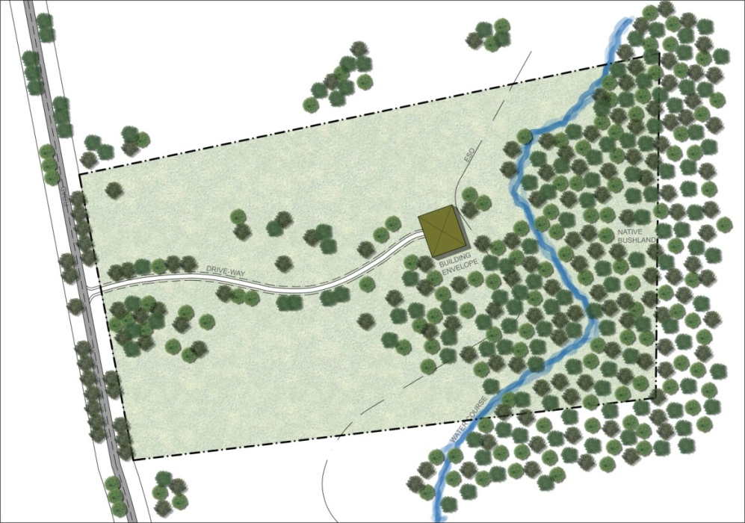
Image 1: Houses and other buildings should be sited as far as possible from main roads and be integrated into the landscape to create minimal disturbance to the existing visual character of the Valley.

Orientation | - To present a visually aesthetic presentation to the road and other significant public viewing points.  - To minimise the impact of construction and the built form on the existing topography.  - Promote the benefits of ecological sustainable design by maximising solar access and passive cooling opportunities. | - Orientate new dwellings and buildings to make the most of views to the surrounding landscape, but make sure the built form will not be visually obstructive from roads and other viewing points.  - Avoid extensive cut into slopes to create a flat bench for buildings. Rather, orientate buildings along the slope and consider stepping the building to work with the existing slope.
Views | - To protect significant views and vistas | - Applicants are recommended to identify the significant views from the site and the visual catchment of the site as viewed from external points.  - Ensure new development is sited in locations of low visual impact from key viewing points such as roads and surrounding peaks.

Topography | - To ensure minimum site disturbance occurs when siting buildings and dwellings.  - To maximise integration of built form with the site and the surrounding land form. | - Consider site topography when siting new buildings and dwellings, and avoid dominating skylines or ridgelines with the built form, or forming large excavations that will create visual scars in the landscape.  - Developments should not be placed on major high points or interrupt the natural skyline.  - Topography also affects sustainability aspects of the built form and needs to be considered in the context of:  - Erosion/landslip potential  - Vegetation cover and associated habitat  - Access  - Visibility of the development  - Landscaping
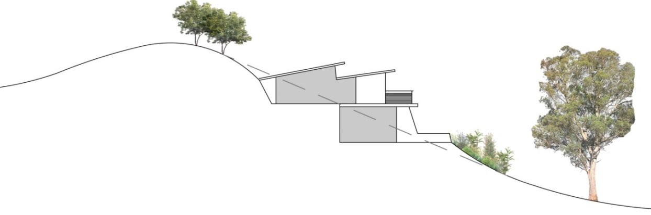
Image 2: Design the built form with a site’s slope and aspect, and ensure buildings are sited below the skyline to assist with its integration into the landscape.
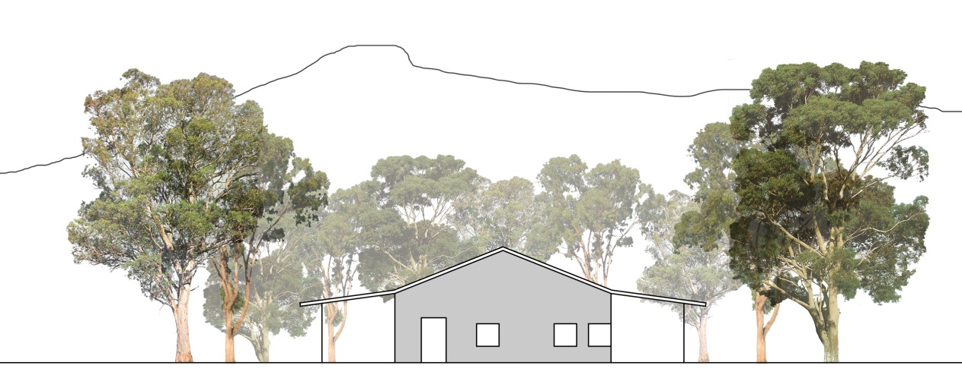
Image 3: On flat sites, use low lying architectural styles that reflect the surrounding elements (such as distant peaks) and blend in with the surrounding landscape.

- BUILT FORM / DWELLING DESIGN

House and building design is an important factor in determining the character of a local area. Houses and out buildings should complement the general character of the area so as to enhance and reinforce the local context and identity. The use of rural architectural styles and building materials will add to the charm, attractiveness and experience of the Wartook Valley.
Avoid eclectic architectural styles that are not of the rural and natural environmental context, such as suburban, mock heritage or foreign building designs.
The natural environment should be the dominant feature of the area, with dwelling and building design drawing inspiration from natural features and seeking integration though visually subtle built form.
Key features to consider in designing new houses and buildings are:
- Building Mass
- Architectural style
- Glazing
- Appearance of built form from the road and public areas
- Building heights
- External walls
- Roof form
- Garages and car parking
- Driveways
- Environmentally sustainable design
- Out-buildings and sheds

CHARACTER ELEMENTS | OBJECTIVE | DESIGN RESPONSE
Architectural Style | - To be responsive to local character and to the natural environment.  - Reinforce the character and environment with an appropriate building style that is evocative of the local context.  - To promote the local vernacular such as rural working sheds (corrugated iron, timber) | - Assess existing building styles in the area and include architectural design features that are typical of the local vernacular and land uses.  - Refer to the local vernacular (design ‘language’) for clues about architectural style, eg. corrugated iron working sheds, rural homesteads with a low wide wrap around veranda.  - Refer to the following web site for information about rural architectural styles: http://www.houzz.com.au/ideabooks/32719107/list/roots-of-style-how-did-your-rural-australian-home-get-its-look  - Consider the local environment (sun, wind, rain) when designing houses and buildings to ensure they respond in a positive way to site conditions, and incorporate ecologically sustainable design principles for economic, as well as aesthetic reasons.
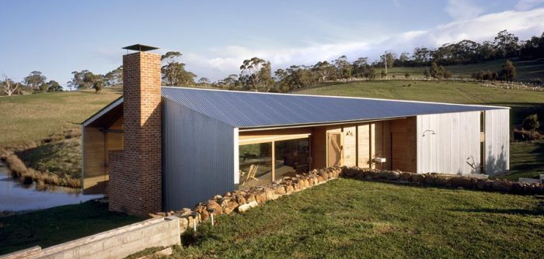
Image 4: A contemporary interpretation of a rural working shed (Design by John Wardle Architects)
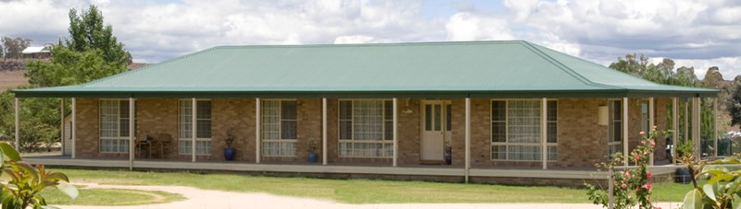
Image 5: A typical Australian style rural homestead
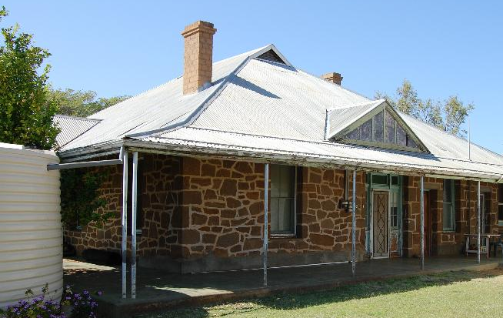
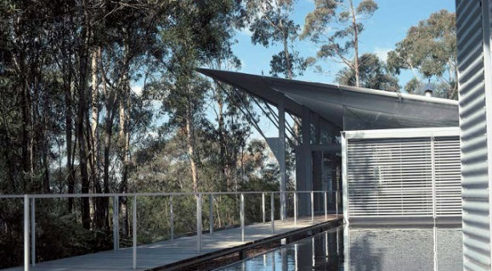
Image 6: Traditional style Image 7: The use of corrugated iron and steel in a contemporary way (Design by Glenn Murcutt)

Appearance of built form from the road and public areas | - To ensure new development is sited in locations of low visual impact from key viewing points.  - To ensure the visual aspect from the road and other public viewing points are aesthetically pleasing and contribute to an overall appreciation of the Valley experience. | - Set dwellings and buildings as far as possible from the road.  - Consider the presentation of dwellings and buildings to the road and other external viewpoints in order to provide an attractive outlook that does not detract from the overall appreciation and amenity and of the landscape amenity.  - Implement the planting of trees and shrubs to assist with the integration of the built form with the overall landscape scene.

Building Mass | - To integrate dwellings and buildings with the scale of the landscape, creating unobtrusive houses nestled within the natural landscape setting. | - Good building proportions are essential for producing house and building designs that relate to the environmental and human scale.  - Avoid large massive buildings that dominate the landscape, vistas and the local environment.  - Consider breaking up the house and buildings into smaller components that relate to the site context.  - Buildings should be grouped into smaller components to minimise the visual impact on the landscape.
Building Height | - To ensure that dwellings and buildings are constructed within maximum heights and don’t create distractions within the landscape. | - Dwellings and buildings shall not exceed two storeys with a maximum height of 5 metres above finished ground levels.  - Dwelling and buildings should not be constructed to heights that breach ridgeline or hilltops when viewed from roads or other significant viewpoints.
Windows & Glazing | - To assist with the articulation of buildings and houses, and to break up large expanses of building walls.  - To avoid the use of reflective surfaces that creates distractions in the landscape. | - Install windows to break up large wall surfaces and to take advantage of scenic views and vistas.  - Colours of window frames should be complementary to the building, and highly reflective bright colours should be avoided.  - All glazing should be of non-reflective glass.

External Walls | - To add visual interest to dwellings and built form and to reinforce the local character.  - To assist with the integration of built form into the landscape setting | - A complimentary combination of materials are encouraged to be used for the external walls and façade articulation  - This includes the use of:  - Corrugated iron  - Weatherboard cladding  - Natural timber and stone  - Rendered, bagged or painted brickwork, cement or stone  - Natural soil: rammed earth, mud brick  - Glazing / windows
Image 8: Corrugated iron Image 9: Natural Stone
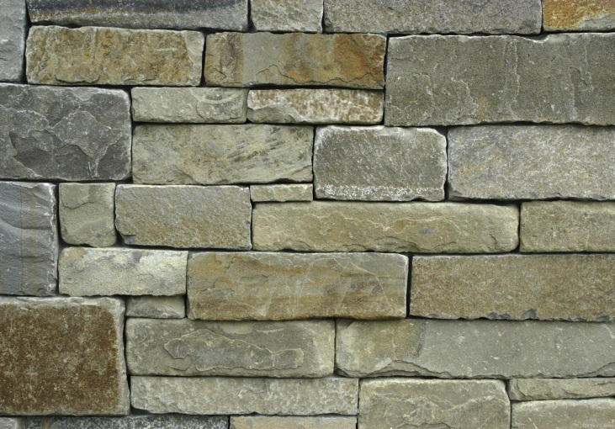
Image 10: Weathered timber and glazing (Wolveridge Architects) Image 11: Mud brick

Roof Form | - To ensure the roof form compliments the dwelling and building architecture  - To complement the overall aesthetic of the building form within the site context. | - Consider the roof form and the visual impact it will have in the landscape (especially from roads and public viewing points).  - Incorporate roof forms that reflect the angles of the surrounding landscape so as to integrate the built form with the surrounding landscape.  - Articulated roof shapes such as flat or skillion rooves are best suited for this, but other forms such as hip, gable or even slightly curved may be appropriate.  - Roofs with wide eaves of at least 600mm are encouraged as it has practical implications for environmental issues; providing shade in the summer and shelter in the winter.
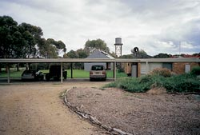
Image 12: A gable roof with a wrap-around veranda is typical of rural homesteads (by Bosworth Hoedenaker)

Image 13: A flat roof presents simple clean lines within the landscape setting (Somers ‘Shed’ by NMBW)

Image 14: A simple warped plane roof that reflects the surrounding land forms
(John Wardle architects)

Driveways | - To align driveways that heightens the sense of arrival.  - To reduce the visual impact of driveways when viewed from roads and distant viewpoints. | - When siting driveways, consider how it will be seen from the roadway and other distant viewpoints. Attempt to reduce the visual impact of the driveway in the overall landscape setting.  - Plant trees alongside the driveway to reduce the visual impact of it and to assist with integrating this element into the landscape.  - Share access points to adjoining properties wherever feasible to minimise the appearance of multiple cross overs that dominate road frontages.
Image 15: This driveway is well integrated into the surrounding landscape and includes additional elements such as the dam and scattered trees to add interest and heighten the rural experience.

Image 16: The sweeping curve of this driveway as it approaches the house and the material selection (including colour) reinforce the sense of arrival and the house’s context in its rural setting.
(Caterpillar House)

Garages and Car Parking | - To reduce the visual impact of large expanses of paving areas for car parking purposes. | - Car parking should be located out of view and well screened from public roads and viewing points.  - Landscape car parking areas to reduce the visual impact of paved areas.
Colours and Materials | - To promote the use of materials and colours that assist with the integration of the built form with the natural landscape setting.  - Require buildings and structures to be constructed of materials and colour which minimises visual intrusion to the landscape. |  | - Building materials should blend as much as possible with the landscape, ie. timber, corrugated iron roofing, gravel ground surfaces.  - Materials of a receding colour such as earthy browns, olive greens and natural timber colours are appropriate.  - The choice of external colours for dwellings and buildings should respond to the colours and textures of the natural landscape.  - Those parts of dwellings and buildings which can be seen from the road and external viewing points should use colours from the suggested palette.  - Highly polished reflective finishes are to be avoided.
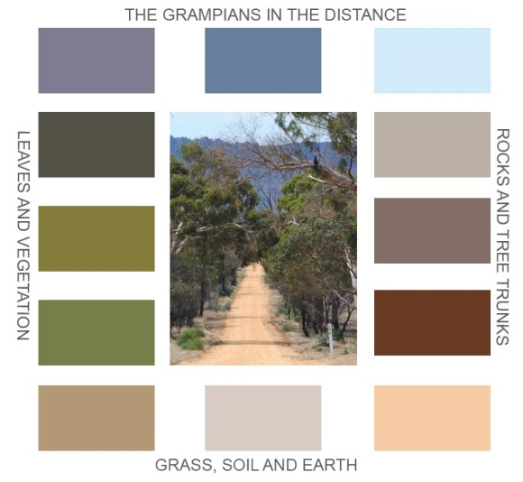

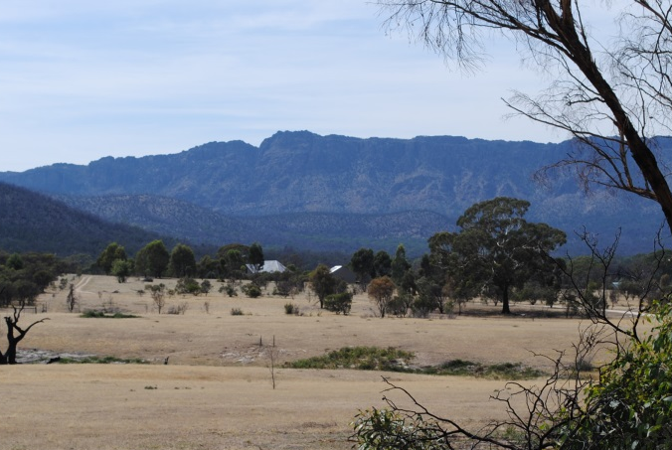 |  | 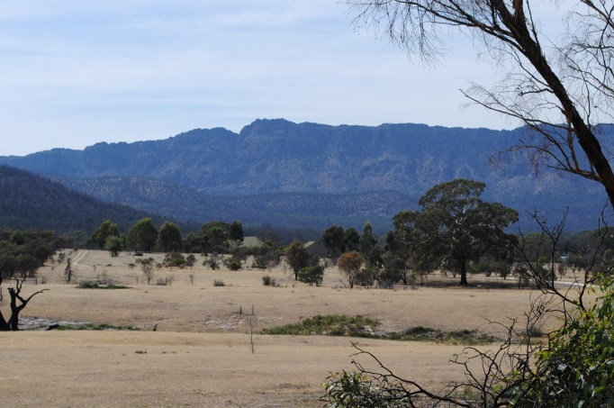
This photo illustrates how natural earthy colours can be used to integrate and blend in buildings with the landscape:
- On the left is a light coloured house roof that stands out in the landscape setting
- On the right is a PhotoShopped image of the same house, but with natural colours to the roof

- LANDSCAPE
The natural landscape and rural character of the Wartook Valley are values appreciated by residents and visitors, and are considered significant attractions. As such, it is important to protect, retain and enhance the environment and landscape amenity so that the social, environmental and economic needs of the valley are met.
Where encouraged, new developments should seek to blend in with the existing landscape and not dominate it. Any landscaping associated with new dwellings and buildings should look like a visual extension of the existing landscape so the new development appears to nestle comfortably into the natural surroundings.
Landscape can be used to screen elements from significant view points and to reduce the visual impact of developments, so it is worthwhile giving thought to how planting can be done to assist with integrating the built form with the natural environment.
Landscape elements such as fences, walls and signage should seek to reinforce the local character and provide a consistent and clear message about local context.
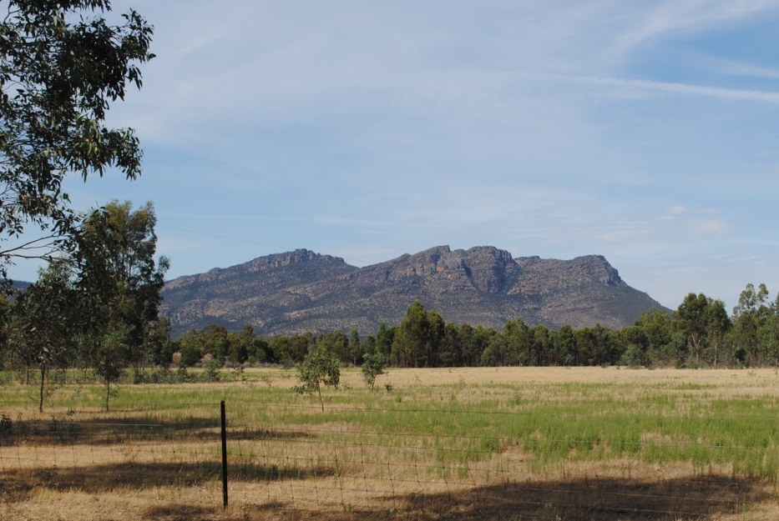
Image 17: New and existing developments should consider how they can sit within open pasture landscape settings, with natural bush and mountain peak backdrops.
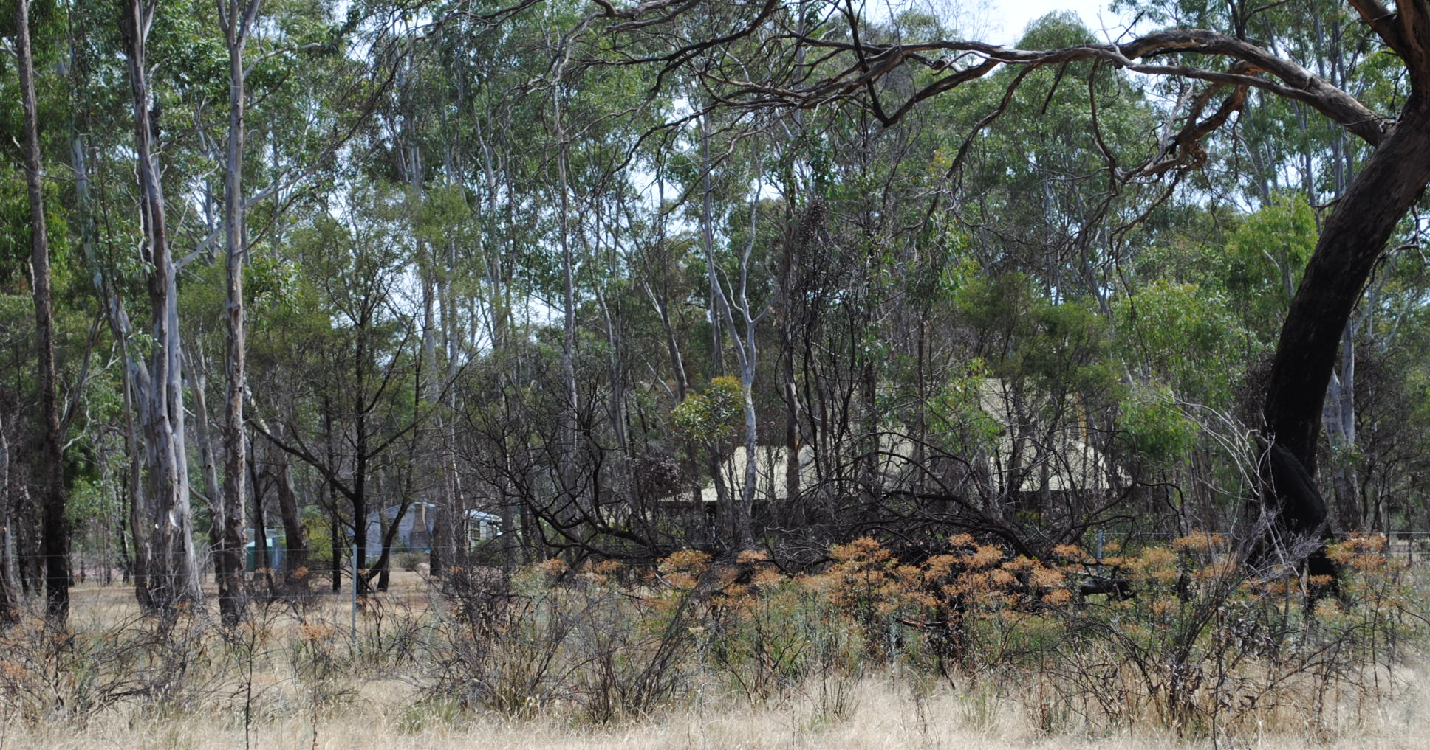
Image 18: Houses within bush settings are easier to integrate with natural colours and appropriate materials.
CHARACTER ELEMENTS | OBJECTIVE | DESIGN RESPONSE
Planting | - To integrate built form developments within the natural landscape through the thoughtful use of planting.  - To provide added visual interest (colour and texture) to the built form environment.  - To enhance ecological values. | - Planting around private development is encouraged. It should be clumped, not planted in rows and should avoid single species.  - Planting and outdoor space design should reinforce the identity of the local landscape character.  - Landscaping can be used to provide colour, define spaces and to screen elements from viewing points.  - Consider the impact of development and activities on significant flora and fauna and areas of habitat. Aim to have no impact/minimal impact.  - Consider using native and indigenous vegetation to reinforce the local character  (see the indicative plant schedule below).  - When selecting plants, gain an understanding of the soil type, aspect and topography to ensure the right plant species are chosen for the right location.

Pant List for Wartook Valley  Legend Sandy Soils S Sandy Loam or Loamy Soils L Clay C  Creepers and climbers  Clematis microphylla S L C Cream twining climber  Hardenbergia violacea (Happy Wanderer) S L C Purple climber  Pandorea jasminoides S L C Pink climber Can suffer from severe frosts  Pandorea pandorana SLC Responds to pruning various color forma available  Groundcovers  Banksia blechnifolia S L .3-.5 x 2-4m Pinkish  Banksia repens S L .3-.5 x 2-4m Cream  Dampiera alata S L Suckering plant Blue  Dampiera coronata S L Suckering plant Blue  Dampiera pedunculata S L Suckering plant Blue  Dampiera rosmarinifolia S L Suckering plant Blue (other color forms available)  Darwinea taxifolia S L .3 x 1m Shades of red  Eremophila glabra (Kalbarri Carpet) L C Gold .3 X 3m  Eremophila subteretifolia LC .5 x 3m Green  Gastrolobium truncatum S L C Prostrate x 2m Yellow & orange  Hemiandra pungens S L Prostrate x 2m Mauve  Homoranthus flavescens S L .3 x 1m Lemon  Kennedia prostrata S L Prostrate x 2m red  Kunzea pomifera S L .2x2.5m  Leptospermum rotundifolium (Julie Ann) S L .5 x 2-3m Pink  Myoporum parvifolium (creeping Myoporum) S L .2 x 3-4m White Other forms available  Tufted Plants  Anigosanthos flavida S L to 2m Yellow/green  Anigosanthus manglesii S L 1m red & green  Anigosanthos Regal Claw SL 1m Orange  Dampiera lanceolata S L Suckering blue  Conostylis bealeana S L .2 x.3m Yellow  Conostylis candicans S L .3 x.5m Yellow  Conostylis robusta S L .3 x .5m Yellow  Conostylis setigera S L .2 x .3m Lemon  Dianella revoluta S L 1 x1m Strappy plant Blue  Tetatheca thymifolia S L .3 x to1m suckering pink | 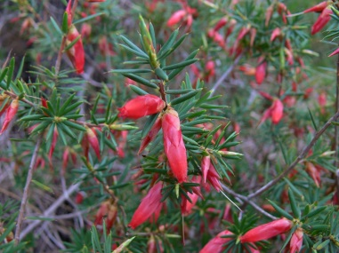  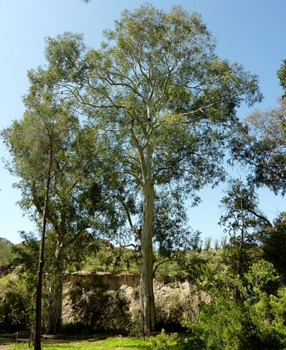  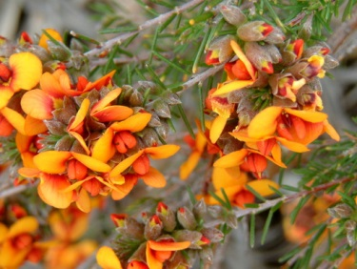  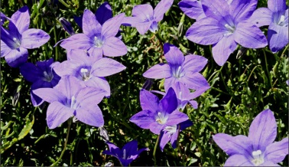  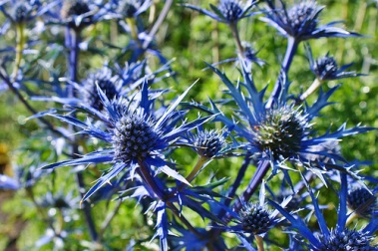
Small Shrubs Under 1m
Acacia glaucoptera S L 1 x1m Yellow Attractive new growth
Acacia lasiocarpa S L .5 x 2m Yellow
Boronia megastigma S L 1 x 1m Brown, yellow
Babbingtonia camphorosmae S L C .5 x 1m Pink
Beaufortia schaueri S L 1 x1m Mauve
Beaufortia purpurea L 1 x 1m Maroon
Calytrix tetragona S L 1 x1m White and Pink forms
Chorizema cordatum S L 1 x .5m Yellow/orange
Correa pulchella S L .5 x 1m Reddish orange
Correa reflexa S L C .5 x 1m Red & green
Crowea exalata S L to 1 x 1m Pink several forms available
Crowea saligna S L 1 x 1m Pink
Eutaxia microphylla S L Yellow Forms available
Eutaxia obovate S L 1 x 1.5m Orange /yellow
Hypocalymma angustifolium S L 1 x1.5m Pink/white
Hypocalymma xanthopetalum S L .5 x 1m Yellow
Lechenaultia biloba S L 1 x 1m Shades of blue
Lechenaultia formosa S L .5 x .6m Many colour forms
Melaleuca conothamnoides S L C 1 x 1m Pink
Melaleuca violacea S L C .5 x 1m Mauve
Miromyrtus ciliata S L .5 x 1m White/pink
Philotheca nodiflorus S L .5 x 1m Blue
Pimelea “Bon Petite” S L 1 x 1m Pink
Prostanthera aspalathoides S L .5 x 1m Various color forms
Pseudanthos pimeliodes S L 1 x 1m White
Stenanthemum scortechini S L 1 x1m White
Thomasia grandiflora S L .5 x 1m Pink
Thomasia pygmaea S L .3 x 1m,Pink
Thryptomene baeckeacea S L .5 x1m Pink
Thryptomene hyporhytis S L C 1 x 1m Pink
Thryptomene strongolophylla S L .6 x 1m Mauve
Verticordia chrysanthera S L .5 x 1m Yellow
Verticordia plumosa S L 1 x 1m Pink

Medium Shrubs 1-3m
Acacia acinacea L C .5-2 x 2.5m Yellow
Acacia ashbyae L C 1.5 x 2.5m Yellow
Acacia beckleri L C 2 x 3m Yellow
Acacia cardiophylla C 1-2 x 3m Yellow
Acacia euthycarpa ( syn calamifolia) S L C 2-3 x 3m Yellow
Acacia gladiformis L C 2 x 3m Yellow
Acacia leprosa Scarlet Blaze S L 2.5 x 4m Red
Acacia merinthophora S L 2-3 x 3m Yellow
Acacia rigens S L C 1.5 x 3m Yellow
Acacia spectabilis S L C 3 x 3m Yellow
Adenanthos sericea S L C 2-3 x 2-3m Pink
Astartea fascicularis S L 1-2 x 2m Pink
Alyogyne huegelii S L 2.5 x 3m Mauve
Banksia ashbyi S L 2-3 x 3m Orange
Banksia sceptrum S L 2-3 x 3m Yellow
Beaufortia orbifolia S L 2 x 2m Red /Yellow
Boronia Telopea Valley.Star S L 1.5 x 2m Pink
Calothamnus gilesii S L 1-2 x 2m Red
Calothamnus hamolophyllus S L C 1-2 x 2m Red
Calothamnus quadrifidus S L 2 x 3–4m Red or Yellow
Chamelaucium uncinatum S L C 1-2 x 2.5m Various color forms
Eremaea beaufortioides S L1.5 x 2m Orange
Eremophila delisseri S L C 1.5 x 2m Mauve
Eremophila maculata L C 2-3 x 2-3m Various color forms
Eremophila nivea S L 1.5 x 2m Mauve
Eremophila Beryl’s Blue S L1.5 x 1.5m Blue
Eucalyptus kruseana L C 2-4 x 3-4m Yellow
Eucalyptus macrocarpa S L C 2-4 x 3-8m Red
Eucalyptus synandra S L 2-6 x 2-5m Cream/pink
Grevillea magnifica S L 3 x 3m Pink
Grevillea olivacea S L C 2 x 2m Red or Yellow
Grevillea Moonlight S L 2-3 x 3m Cream
Grevillea White Wings S L C 2-3 x 3m White
Hakea bucculenta S L 2-3 x 2-3m Red/orange
Hakea francisiana S L C 2-3 x 2- 4m Various color forms available
Hakea minyma S L 2-3 x 3 Cream
Hakea orthorryncha S L 3 x 3-4m Red
Kunzea pauciflora S L 1-2 x 1-2 Pink
Kunzea pulchella S L 2-3 x 2-3m Red
Leptospermum myrsinoides S L 1-2 x 1-2m White but occasionally pink
Leptospermum rotundifolium S L 2-3 x 2-3m Mauve
Leptospermum spectabile S L 2-3 x 2-3m Maroon
Melaleuca coccinea L C 1-2 x 2m Red
Melaleuca fulgens’ S L C 2-3 x 2-3m Various color forms available
Melaleuca megacephala L C 1-2 x 2-3m Yellow
Melaleuca nesophila S L C 2-3 x 2-3m Mauve
Melaleuca spathulata S L C 2-2.5 x 2-3m Pink
Melaleuca wilsoni L C 2-3 x 2-3m Red
Mirbelia dilatata S L 1-2 x 1m Pink
Mirbelia oxyloboides S L 2 x 2-3 Orange
Philotheca verrucosa S L 2 x 2-3 White
Phymatocarpus maxwellii S L 1-2 x 1-2m Pink
Prostanther rotundifolia S L 2-3 x 2-3m Mauve

Prostanthera Poorinda Ballerina S L 1-2 x 1-2m White
Thryptomene calycina S L1-2 x 2-3m White
Regelia megacephala S L 2-3 x 1-2m Maroon
Regelia velutina S L 2x 2-3m Red Needs protection from severe frosts
Ricinocarpus pinifolius L C 2-4 x 2-4m White

Large Shrubs and Small Trees 3-10m
Acacia argyrophylla L C 3-5 x 3-5m Yellow
Acacia denticulosa S L 3-5 x 2-4m Yellow
Acacia cheelii L C 5-10 x 5-8m Yellow
Acacia pendula S L C 6-10 x 3-5m Lemon
Acacia podalyrifolia L C 3-6 x 4-8m Yellow
Acacia pycnantha S L C 3-5 x 3-5 Yellow (Australia’s Floral Emblem)
Banksia baxteri S L 3-5 x 5-8m Yellow
Banksia burdettii S L 3 x6m Orange
Banksia prionotes S L 3-6 x 5-8m Orange
Banksia speciosa S L 3-5 x 3-5m Yellow
Callistemon phoniceus L C 3-4 x 3-4m Red
Callistemon rugulosus L C 3-5 x 3-5m Pink/red
Callistemon Harkness hybrid L C 4-5 x 4-5m Red
Dryandra Formosa S L 3-4 x 2-4m Yellow
Dryandra praemorsa S L 3-4 x 3-5m Yellow
Eremphila dempsteri L C 3-4 x 4m Mauve to White
Eremophila longifolia L C 4 x 3m Mauve
Eremophila youngii L C 4 x 2-3m Pinkish red
Eucalyptus burdettiana S L 3-9 x 3-10m Green
Eucalyptus caesia S L C 3-5 x 3-5 Pink
Eucalyptus caesia ssp magna (Silver Princess) S L C 3-10 x 4-8m Deep pink to red
Eucalyptus crucis S L 3-5 x 3-5m Yellow
Eucalyptus eremophila L C 4-8 x 5-8m Yellow
Eucalyptus erythocorys S L C 4-10 x 3--9m Yellow with red caps
Eucalyptus erythronema L C 4-10 x 4-9 Red
Eucalytus ficifolia S L 3-10 x 5-15m Various color forms Some grafted
Eucalyptus gardneri S L 6-9 x 4-8m Cream to yellow
Eucalyptus grossa L C 3-5 x 3-5m Yellow
Eucalyptus macrandra S L 4-6 x 5-8m Yellow
Eucalyptus orbifolia S L 3-6 x 4-8m Yellow
Eucalyptus torquata S L C 6-10 x 6-10m Red
Eucalyptus websteriana S L 3-5 x 3-5m Cream
Hakea laurina S L C 4-6 x 5-8m Red & Cream
Hakea macreana S L C 4-6 x 5-8m White
Hakea multilineata S L C 3-4 x 3-4m Pink
Hakea petiolaris S L C 4-8 x 5-8m Cream/purple
Melaleuca decussata S L C 3-5 x 3-5m Mauve
Melaleuca huegelii S L C 3-6 x 4-6m White
Melaleuca linarifolia S L C 4-10 x 5-12m Snow in Summer White

Medium Trees 10-30m
Acacia glaucescens S L C Silver foliage Lemon
Eucalyptus astringens S L C Cream
Eucalyptus leucoxylon S L C Various color forms
Eucalyptus maculata (Spotted Gum) S L C Cream
Eucalyptus occidentalis S L C Yellow
Eucalyptus petiolaris S L C Cream, Yellow, Apricot or Red

Large Trees 30m plus
Angophora costata S L C Cream
Eucalyptus camaldulensis S L C Cream
Eucalyptus citriodora S L C Cream

Gates, fencing and walls to front entrances | - To encourage the installation of front gate walls and fences that reflect and reinforce the natural and rural landscape character of the Valley.  - To promote attractive and interesting front entrances to properties – particularly along the Northern Grampians Road and Roses Gap Road where more passing traffic is likely to see them. | - Install entrance gates, fencing and walls that reflect the natural and farming character of the Wartook Valley.  - Use natural materials and colours for front gates, walls and fences that provide interest and identity, and do not detract from the general environment and experience.  - Avoid installing front gates, walls and fences that use suburban styles.
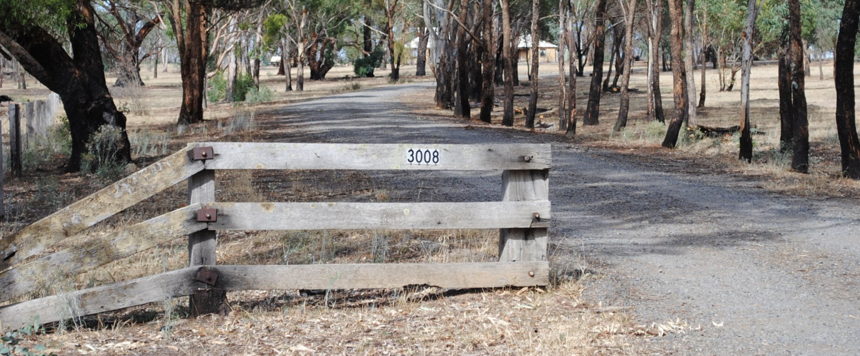
Image 19: Natural materials that reflect the local rural context and identity are more likely to heighten the experience of living and visiting the Wartook Valley.

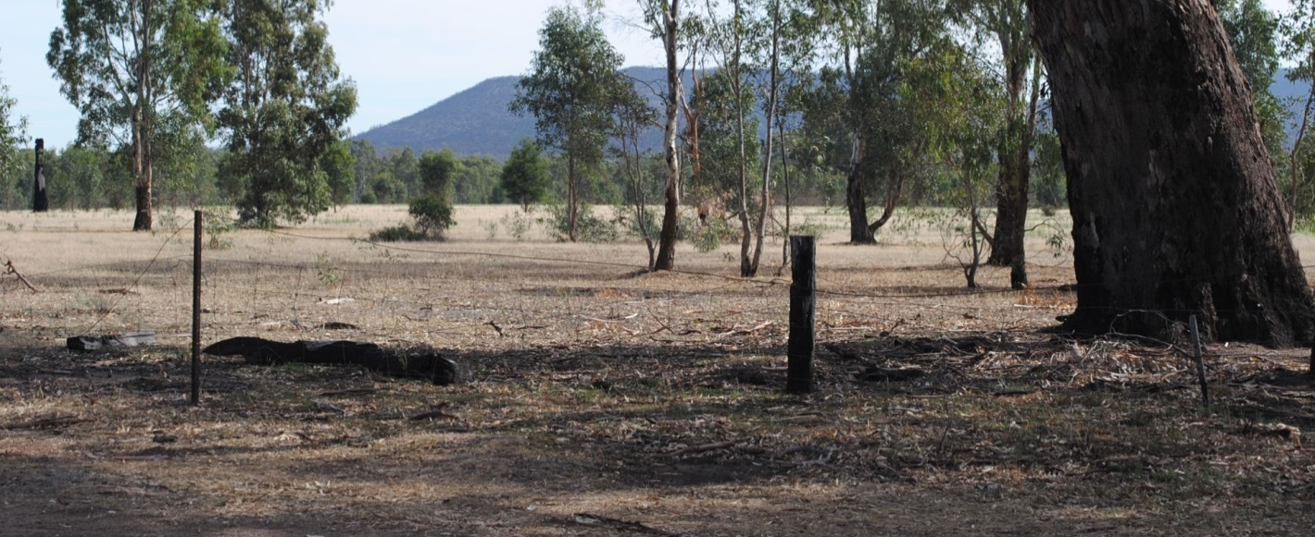
Image 20: Simple farm style post and wire fences ensure visual connection from the road to the adjoining landscape and reinforce the rural identity and experience.

Signage | - To provide clear and concise information about local facilities and amenities.  - To reinforce the local character by providing an appropriate suite of signage types and design style.  - To avoid visual disorder alongside the roads that is confusing and detracts from the overall experience of the Valley. | - All signage is to be consistent with the Grampians Way Signage Scheme  - Consider designing a suite of roadside signs that reflect and reinforce local identity and character, and provide visual interest and attraction for visitors to the Valley.  - Avoid a multitude of signs and signage styles that could be found anywhere.  - Avoid roadside signs that can’t be read by passing traffic.
Image 21: Most of the information in this collection of signs will be illegible at 100 km/hr.

Image 23: Explore opportunities for interesting information signs to create interest, reinforce local character and provide clear information.

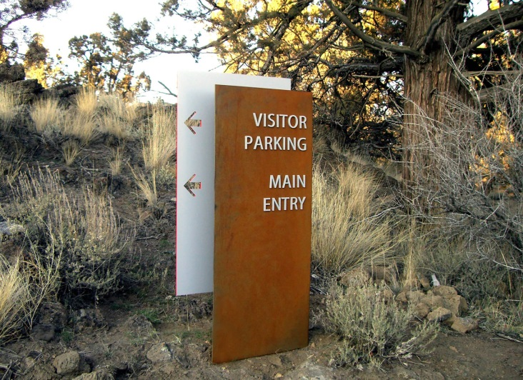
Image 22: A large title panel that can be clearly seen from a distance, followed by more detailed local information will be more successful than a multitude of small signs.

Signage is to be consistent with the Grampians Way Signage Scheme.

Image sources:
1-3 GroupGSA diagrams
4. http://www.johnwardlearchitects.com
5. http://www.domain.com.au
6. http://www.domain.com.au
7. www.archdaily.com
8. tinyhouseswoon.com
9. www.selectstone.com
10. wolveridge.com.au
11. raywhiteruralqld.com.au
12. www.houzz.com.au
13. architectureau.com
14. www.johnwardlearchitects.com
15. luigirosselli.com
16. www.archdaily.com
17-21: GroupGSA images
22: www.wayfound.com.au
23. signsandscreens.com.au

