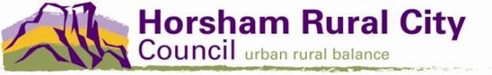
The Station Community Engagement Mural:
Background
Site Overview
Artist Selection
Key Project Deliverables
Contact Information
Expressions of interest close:
09/10/2020
Contact Information
For further information please contact
Annie Mintern, Youth Services Engagement and Planning Officer
0418 648 815 annie.mintern@hrcc.vic.gov.au
Background
In 2018, Horsham Rural City Council developed its first Youth Strategy.
One of the key objectives of this strategy was to develop a contemporary and future facing models for youth service delivery that reflect the needs of a diverse regional city population and take into consideration equity and access. The Station has arisen from this process.
The Station building in Pynsent St was previously known as Nexus Youth Centre and has been renovated and rebranded to reflect the aims of the Youth Strategy in providing a multipurpose space accessible to the community to deliver programs and services including for young people and out of hours services.
The building has recently been painted on both the exterior and interior and we are seeking to install artwork on both the front exterior wall of the building and the interior of the same wall.

THE PROJECT DESCRIPTION
We are currently running a Design a Logo competition with young people in the region to develop a design to be installed on the exterior wall that becomes the brand identity of the building. The successful artist will be required to workshop a design with the Horsham Youth Council and any other young people in the community who would like to be involved, to be installed on the interior wall of the building.
Summarized key deliverables of the project are:
- Installation of logo artwork on the exterior wall of the building
- Workshop facilitation with young people in the region to develop a design for the interior wall of the building
- Installation of the interior wall mural with collaboration from young people in the region

Artists or artistic teams are required to respond to the Art Selection and Key Project Deliverables

Site Overview
The site is at 14-16 Pynsent St, Horsham and the exterior mural is to be installed on the front of the building. The interior mural is to be installed inside the building on the same wall.

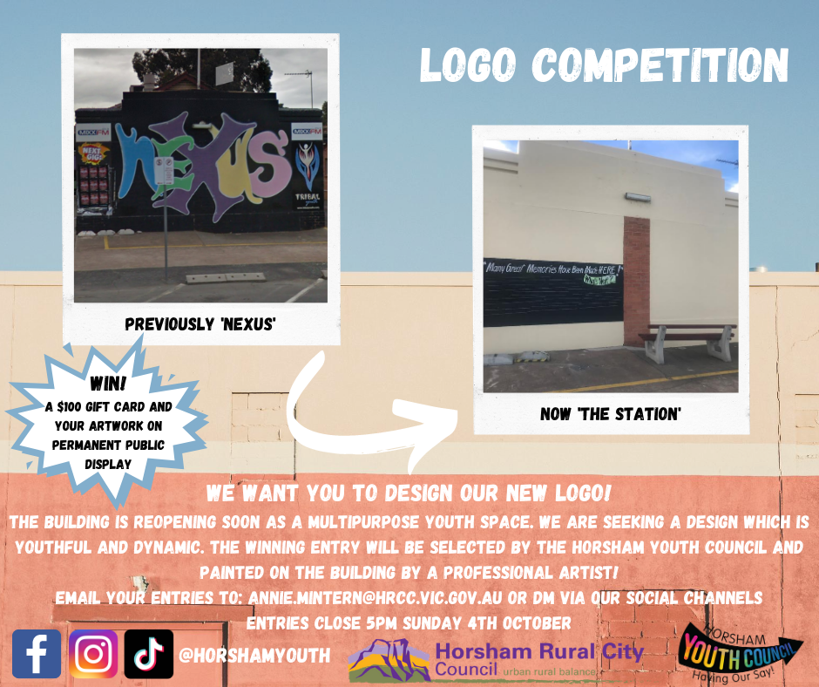

Images of the building prior to renovations:

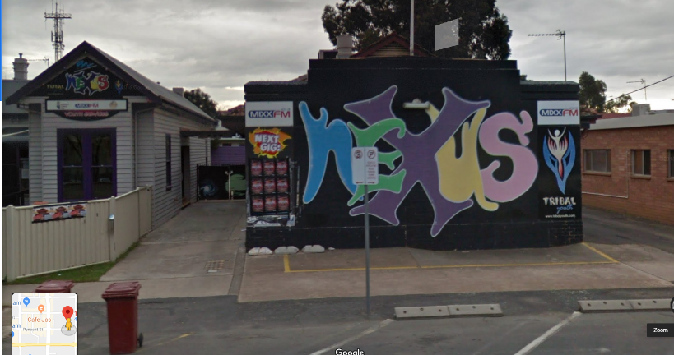
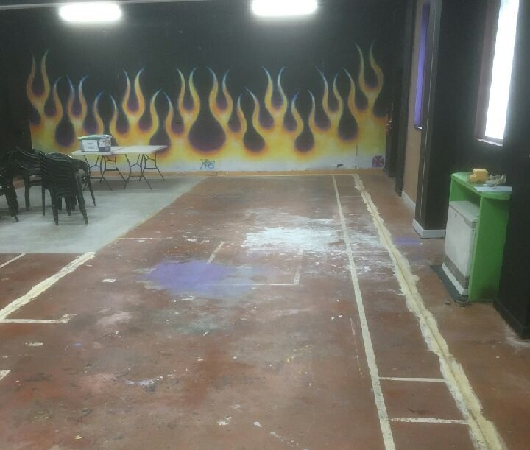

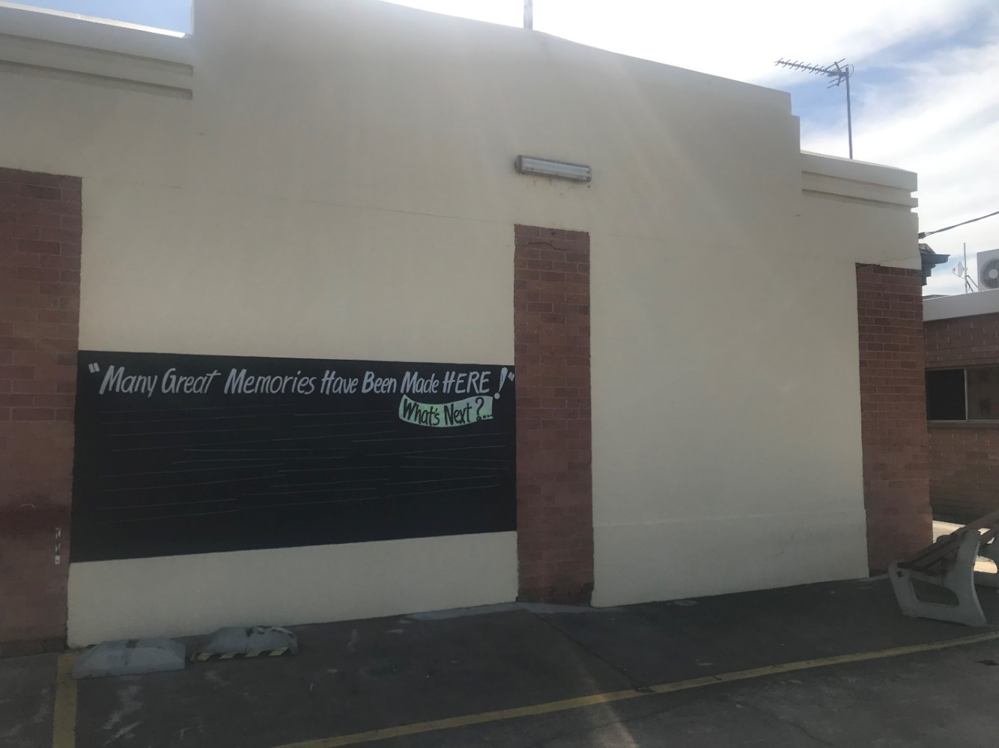
950mm
8900mm
4500mm
950mm

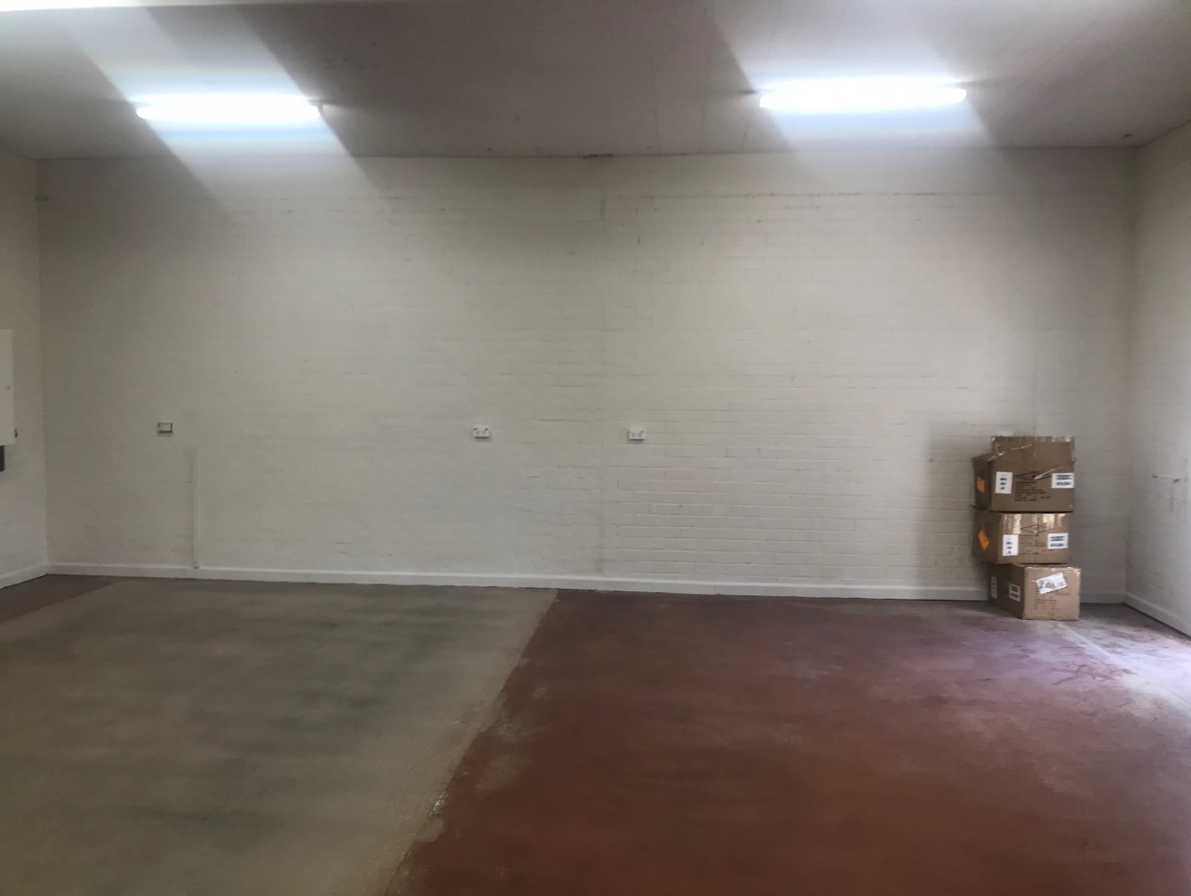
3200mm
8300mm
Artist Selection

Selection will be by the submission of an expression of interest that will be evaluated by the Horsham Youth Council.

Open Call for Submissions
The selection of the artist or artistic team will be based upon their submission of:

- Curriculum vitae, 1-2 pages
- Maximum of 10 images demonstrating the range and character of the artist’s past work, and
- Brief outline of up to 500 words in length describing why the artist would like to participate in the project.
- Please provide a quotation for the delivery of all works described in the Key Project Deliverables section, including a detailed budget specifying Artist Fees, materials costs, any project coordination and administration fees including travel and accommodation costs.
The closing date for the receipt of Expressions of Interest by email at the office of the HRCC shall be by 5 PM on Friday 9th October 2020.

The Horsham Youth Council that will select the artist(s) from the submissions received will be a group of 20 young people aged 12 – 25 years.

The project’s Selection Panel will meet on Monday, 12th October 2020 to select an artist or artists.

The aim of The Station building is to create a multipurpose space where the community, including young people can feel welcome and safe.

Our vision is for the building to be accessible to services and the community to use for activities and events, with a focus on young people.

Selection criteria will include:
- The potential of the artist(s), as demonstrated by the images of the range of their past work, to design work at an effective scale and medium as a permanent installation within a public place;
- The reasons why the artist/artistic team, wishes to participate in the project in relation to the specific areas of interest of the artist’s creative practice.
- Experience in working with young people and engagement skills required to workshop a design for the interior mural.

Key Project Deliverables - Expanded

The successful team shall deliver on the following elements:

PART 1 (EXTERIOR WALL)
- Delivery of an art technique workshop with young people from the region.
- Production of artwork on the front wall of ‘The Station’ hall building. Design ideas will have been generated as the starting point for the mural via a competition with youth in the region.
- Consultation with the logo competition winner to ensure design is up to standard and make any alterations that may be required in collaboration with the designer.
- Opportunity for young people participating in the project to assist with part of the production
- Supply of all workshop materials and mural materials
PART 2 (INTERIOR WALL)
- Delivery of a design workshop with young people in the region to establish a design for the interior wall of ‘The Station’ hall building.
- Production of artwork on the interior wall of ‘The Station’ hall building.
- Opportunity for young people participating in the project to assist with part of the production
- Supply of all materials required for the mural

Design Outputs
The artworks need to be fully documented. For concepts and final design plans, the artist/artistic team shall provide a series of A3/A4 size, colour copies of perspectives and or sketches that best convey the design and artistic intent of the proposed artwork. Digital formats are also suitable. Any supporting information in relation to the conceptual or final design treatments such as dimensions, sections and details, shall be included on the sheets.

Materials
Careful consideration should be given to the mural’s durability and surfaces that require minimal cleaning and are resistant to vandalism and graffiti are essential and must be considered early in the design phase of the project Council will apply a coat of anti-graffiti paint and a separate budget has been allocated to cover this cost.

The finished mural should offer a life span of approx 10 - 15 years. For more information see Maintenance.

Construction and Installation
Community and contractor safety will be extremely important during the installation process and potential hazards discussed in detail before work on site/s is undertaken and a safety plan developed and submitted accordingly prior to installation commencing.

COVID-19
All face to face interaction and events will take place under strict COVID-19 guidelines. A COVID-19 plan has been developed for the building and all artists and participants will be required to adhere to these guidelines.
Maintenance
Following the issue of a Certificate of Final Completion, and settlement of the contractor’s final invoice, Council will assume ownership of the artwork as part of its public art collection and assets of the City. At that point, Council will also accept responsibility for managing ongoing maintenance.

At practical completion the artist/artistic team must provide a detailed report outlining materials, products and finishes used, along with inexpensive cleaning and maintenance instructions for the artwork/s.

Council will include the maintenance report on its inventory of public artworks and ensure that a detailed inspection is conducted annually. Council will be solely responsible for the proper cleaning, maintenance and protection of the work beyond final completion. If any repairs are required Council will give the artist/designer the first opportunity to undertake the repairs, for a fee to be negotiated between the parties.

Visual Documentation
The artist/artistic team working on this project will be required to visually document the various stages of the process and present the information as a series of digital photographs that show the stages of the project and its complexities. Other documentation may include working drawings, sketches and design concepts, accompanied by text describing key stages of the project.

At the conclusion of the project Council, will commission professional photographs of the completed site. A separate budget has been allocated to cover this cost and the images will be made available to the artist/artistic team for future use in their portfolio.

Launch
The artist/artistic team will be consulted in the development of ideas and approaches to the official launch. HRCC will assume overall responsibility for co-ordinating the launch utilising a separate budget.

The launch will be held at the conclusion of the project to ensure that maximum impact is achieved. All parties will be involved, including, artists, contractors, project officers, residents, the media and special guests. Artist/artistic team involved will be acknowledged throughout the project and at the launch. There is an expectation that the artist will be available for media and promotion opportunities throughout the project as well as the preceding week and subsequent launch event.

Attribution
The artist will be acknowledged as the creator of the works along with their team of technicians, assistants and sub-contractors (where these have been used) on council’s website and on printed material. The winner of the logo design competition will also be acknowledged for their design on the exterior mural. Each work will be identified using professional photographic images for these purposes. Each site will be identified with an attribution plaque naming the primary artist or organisation. This will be arranged and paid for by Council.

Copyright
Copyright for designs created shall remain with the artist/designer. Sketches, drawings or additional concept information developed during the project may be copied and kept on file by Council for the express purpose of recording and promoting the project.

Copyright of the design and the work will be vested in the Artist/designer; however the artist/designer shall agree not to make identical work in the future.
Final Work
Council reserves the right to promote and publish designs and material created during the project on council’s website. Further reproductions of the work may be used for any promotional and documentation purpose.

Photographic Documentation
Council reserves the right to commission photographs of the project for any purpose showing stages of the project and the contractors and sub-contractors involved, for use on Council’s website and Council publications including general promotion and documentation of the project. The project is in a public place and may also be photographed, sketched and recorded freely without incurring rolling or ongoing commission or remuneration of any kind.

Relocation/deaccession
Council recognises and values the site specific nature of the artworks and will advocate for their protection and preservation within the time frame of this project. At some future time it will become necessary to remove, relocate and/or deaccession the work. Council reserves all rights to do so and may or may not involve the artist/designers as Council considers appropriate. In the event of artworks being relocated Council will take all reasonable effort to consult and advise the artist/designer prior to the work being moved and a new site being identified.

Project Timing
All works associated with this project shall be completed and installed by the end of December 2020. Upon issue of a Notice of Appointment and provision of documents by the successful artist/designer as required by Council, the project should commence immediately.

Practical Completion
Practical completion will be the completion of the fabrication and installation of the public art work as required by this brief.

Final Completion
Final completion is a date 13 weeks from the date of practical completion. The artist will be required to inspect, repair, make good or reinstate any faulty works or finishes that arise during this 13 week period, being the Defects Liability Period. This work shall be undertaken by the artist/designer at their expense. Acts of vandalism are excluded and will be addressed by Council in consultation with the artist/designer. Council will issue a letter to signify final completion of the project.

Performance
The services of the artist/designer shall be carried out within the agreed budget and a project timeline, which will detail key project stages. The timeline will be used to assess progress and establish progress payments. The works will be fabricated and installed as per the approved drawings and to the level of detail indicated.

Contact Information

Send Expressions of Interest to:
Annie Mintern, Youth Services Engagement and Planning Officer
Horsham Rural City Council
0418 648 815 annie.mintern@hrcc.vic.gov.au

