**ALGA – NGA 2025 – 24th-27th June**

**Tuesday 24th June**

Cr Sluggett and Cr Wilson, accompanied by CEO, Gail Gatt, left for Melbourne early on Tuesday morning to catch our flight to Canberra, which left at lunch time. As the 31st National General Assembly was well attended, we were surrounded by other Councillors, CEO’s and officers on the flight, which provided an excellent opportunity to do some networking before we arrived.

After we settled into the hotel, we made our way to the conference centre to register and be in place for the official opening of the assembly. It was in a hall to the side of the conference hall and was filled with some 74 exhibitors, which were there to discuss everything from Heart Health to machinery communications, to apps which help those looking to make planning applications. The full list of exhibitors is provided below.A list of information on a computer
Delegates attending the National Assembly have the opportunity to vote on motions put forward by member Councils, each Council is allowed one vote. On Tuesday night we realised we were a bit underprepared and needed to review the motions that were to be presented before we started debating the following Wednesday afternoon, so we spent our evening undergoing that review to confirm which way our Council was voting on each of them.

**Wednesday 25th June**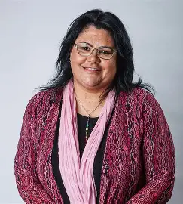

On Wednesday we were back to the conference centre early for the Official Welcome to Country, done by Ngunnawal Woman Selina Walker. Ms Walker is a strong advocate for improving outcomes, both in housing and education, for all children but particularly those of Aboriginal heritage.

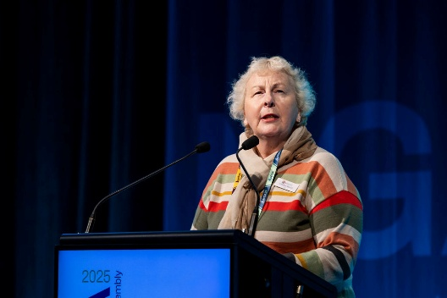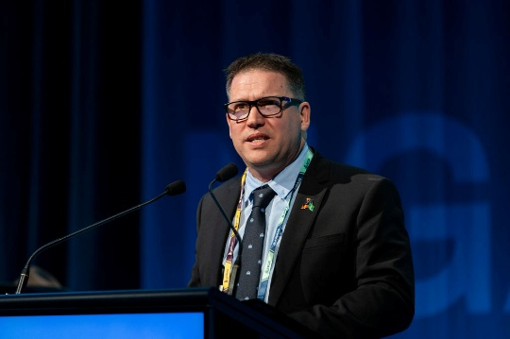We were then welcomed by Australian Local Government Association (ALGA) President, Matt Burnett, Mayor of Gladstone. He informed us that there was 1300 people in attendance representing over 300 Councils from across Australia. He also welcomed Cr Andrea Metcalf, Mayor of Bendigo, to inform the room of another conference in November that was occurring in Bendigo. The Regional Roads Forum is an opportunity for Regional and Rural Councils to come together to transform road management and to maximise maintenance outcomes.

We were then addressed by The Hon Kristy McBain, Local Government minister. Ms McBain was keen to welcome us all to the event and was interested to address the Local Government Financial Sustainability inquiry and how it had been held up since before the election when the interim report was released.

Following this, we were addressed by Dr Anne Webster, Shadow minister for Local Government. Dr Webster stressed that she was very new to the role, less than a month in, and was keen to get to know and learn from as many Councillors and Councils across Australia during her term. She was keen to have the tough conversations and to also readdress the inquiry into Local Government Financial Sustainability that has stalled since the election.

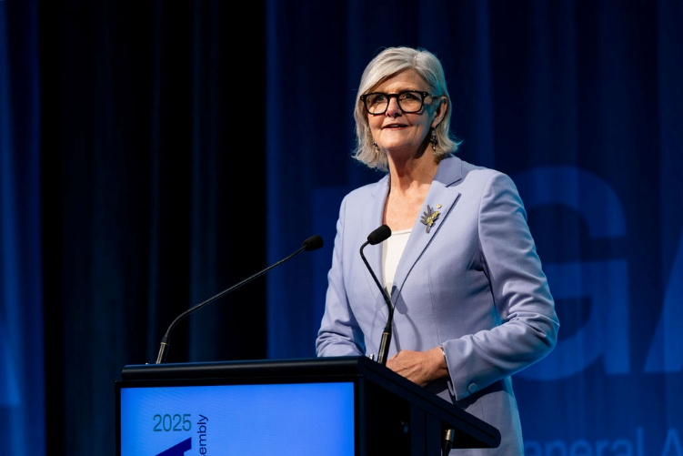Our next speaker was Her Excellency the Honourable Ms Sam Mostyn AC. The Governor-General was expansive when talking about the role Local Government played in community leadership and local engagement, to build national unity and resilience. Ms Mostyn also stressed the importance of civics and how it seems that our younger generations have limited interest or concern about the way in which governance occurs in our Country.

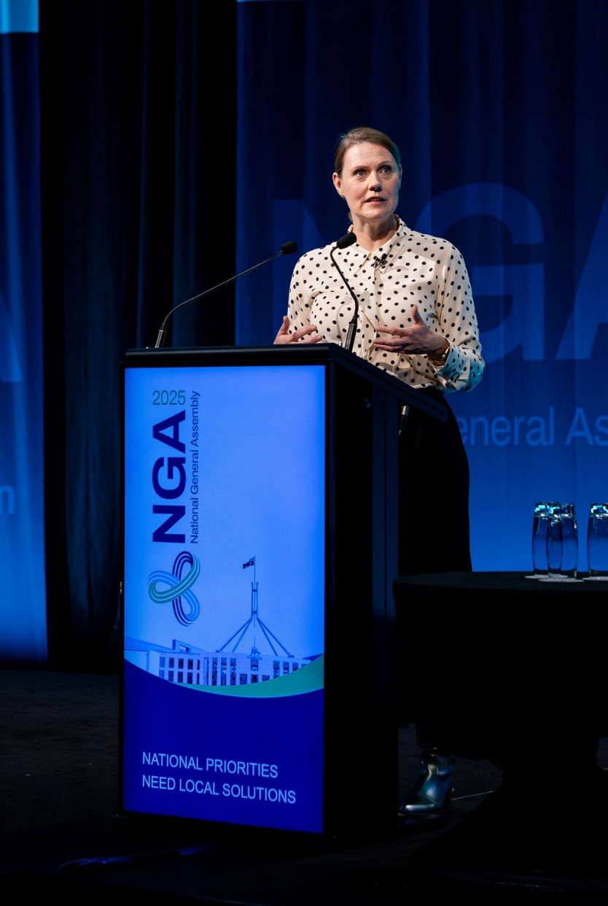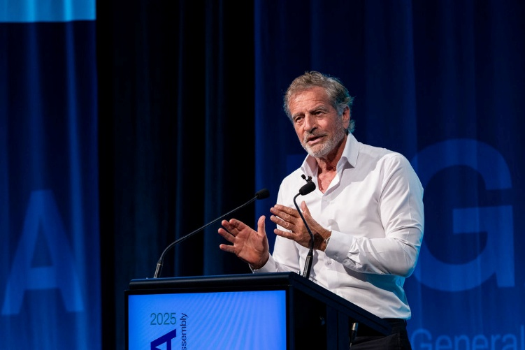Our first guest speakers in the program, Mark Bouris and Dr Merriden Varrall, spoke on ‘Australia and the New Geoeconomic Landscape’. Mr Bouris spoke more on a local to Australia level and addressed the issue that our GDP is, if Government spending is removed from the equation, going backwards. He was calling for our government, at all levels, to work on ways to increase our productivity over all sectors, to get our economy working for us into the future. Dr Varrall took us on a more global perspective and how politics now, is very divisive all over the world. She discussed that there is very little middle ground anymore and as voters we tend to lean toward the more ‘out there’ candidates who look as though they will get things done. She specifically referenced Donald Trump, saying that he is a symptom of this outlook rather than any part of the cause of it. This session was important to show that our economy is struggling and that from the perspective of Horsham Rural City Council (HRCC) the new business due to start in our area, i.e. Farm Frites, are a real positive for our region.

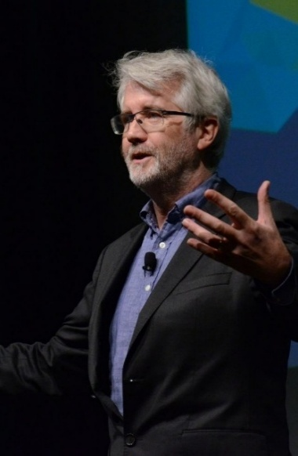Secondly, we heard from Jason Clarke on ‘From Big Picture to Local Action’. Mr Clarke was pressing the point that for Local Government to succeed we need to get the great ideas worked out into solid workable projects. He was pressing the point that there are people who have ideas, people who plan, people who see the barriers and people who act, and that the only way for projects to happen is if we get all these people working together to get the most out of the original idea, but in a way that is the most beneficial for our whole community. He has an IDEA system that uses the strengths of stakeholders at an appropriate time in the process for the best outcomes.

There were 192 motions to be debated over the course of the Assembly, and they had allocated four hours for this to be achieved. Each motion that was passed was to be presented to the Australian Government as an ALGA strategy. The first two hours were on Wednesday afternoon and we managed to get to motion number 92. Some of the motions from day 1 that we believe were of note are as follows:

* Motion 40 called for the decentralisation of government jobs and agencies beyond major cities.
* Motion 43 called for an end to the cost shifting onto Local Councils by the State and Federal Governments
* Motion 48 called for some level of royalties from significant industry to remain within the region in which they are gathered.
* Motion 62.1 called for backing to get the State Governments to prioritise funding for school drop-off/pick-up areas and crossings to be done at no cost to local councils to ensure child safety
* Motion 67 called for mandated road user agreements with industry, meaning higher weight loads would pay more due to the damage they caused to roads. Cr Sluggett spoke against this motion, pointing out that those with high road use already pay more through road fuel excise and that the motion was not clear about who would be paying for these agreements, potentially impacting grain receivals, farmers and industrial businesses. We voted against the motion; however, it was supported by the majority of councils.
* Motion 80 called for a review of the wheelchair accessibility standards and building code to allow for new technology and wider mobility equipment.

After the motions we finished the day by having a meal with some of our neighbouring council colleagues, Yarriambiack and Hindmarsh.

We then returned to the hotel for another long night revisiting the remaining motions due to be brought up Thursday.

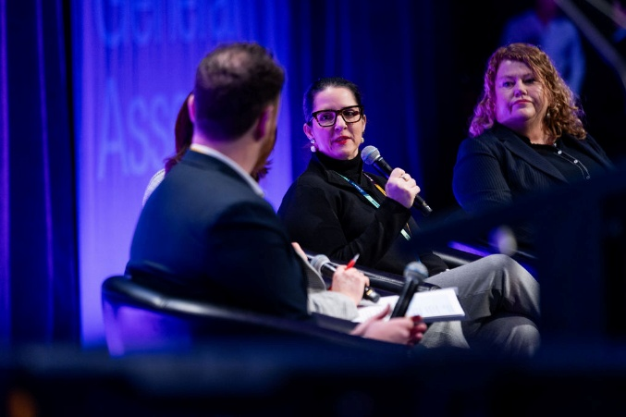**Thursday 26th June**

Our first guest speakers on Thursday morning were a panel on ‘Adapting Together: Local Government Leadership in a changing climate’. The panel included Lord Mayor Anna Reynolds, City of Hobart, Amanda Pugh, Lockyer Valley Regional Council and Keiran Power, Nation Partners. The focus of the discussion was on how Local Councils are facing funding shortfalls trying to make their communities invulnerable to natural disasters. Anna talked of the issues with bushfire preparedness around Hobart and Amanda covered the issues the flooding has caused in the Lockyer Valley. ALGA helped undertake some research into this area and has released its results showing that in the next five years, Councils are expected to spend two billion dollars to future proof our communities. The consensus was that the Federal Government should shoulder some of this burden and implement a new funding stream to distribute across Australia.

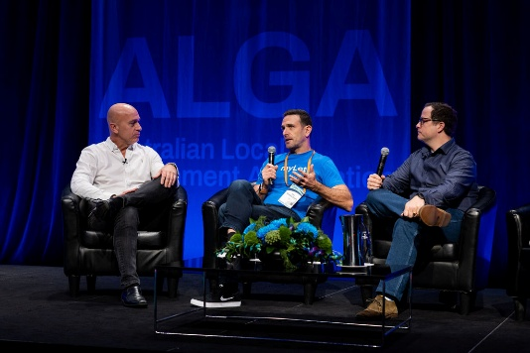The final panel for the day was titled ‘AI for Society: Shaping a Better Tomorrow’. The two panellists for this were Stephen Scheeler, from The Digital and Omniscient and Tim Golsby-Smith, from myLot. Stephen gave us a brilliant run down of his employment history, and of how he was instrumental in getting Facebook off the ground in Australia and New Zealand. It was a discussion where the benefits of AI were explained and how useful it could be from a Local Government perspective.

We then moved onto the listening sessions which were four concurrent sessions over the following two hours. The four sessions were around the issues of Emergency Management, Safer Roads, Housing and Community Infrastructure, and Local Government Jobs and Skills. For the benefit of completing this report, the attached is the ALGA notes of all four sessions. Both Councillors will present on each of the sessions they attended during the Councillor report period of the July 2025 Council Meeting.

Following these sessions, we moved back to the auditorium to complete more debate on the motions, some of the more notable as follows:

* Motion 96 called for councils to implement Affordable Housing Contribution Schemes. We voted against this motion as we saw that housing should not be another way to cost shift onto Local Government and that we should leave housing to the State and Federal Governments. This motion was voted down.
* Motion 99 called for the removal of double taxation on home insurance. Stamp duty for the State or GST for the Commonwealth, one of them should be removed.
* Motion 103 called for satellite university campuses that can utilise existing Local Government infrastructure in outer urban and regional areas.
* Motion 108 called for those with appropriate equivalent competencies to become building certifiers, addressing the national shortage. Cr Sluggett spoke in support of this motion when others opposed it. She refuted claims that this would lead to a degradation of the building certifiers quality of work. Pointing out that there is too often a reliance on piece of paper showing qualifications and disregard people with lived industry experience. The motion was carried.
* Motion 111 called for a national strategy to address the critical shortage of Environmental Health Officers within the workforce. There are numerous areas where this role is required, and it is becoming increasingly difficult to have one employed in a local council.
* Motion 133 called for a review of regulations governing day care centres in rural and remote areas. To do this, it was proposed to streamline models so that they were fit for purpose in rural and remote areas, as these areas differ from urban areas. We voted for this motion, but it was ultimately defeated.

Unfortunately, we needed to leave the motions early to attend a meeting with our local member. We left at the conclusion of the debate on motion 147 to make our way to Parliament House. We were told later that the room lost their quorum not long after and did not finish all the motions. The remaining motions will be decided on by the ALGA board and will be released on their website along with all the rest when they have compiled the list.

We met with Dr Anne Webster and Bridget McKenzie in the National party room with many of our colleagues that have a sitting National member. We took this opportunity to bring up with Dr Webster the proposal to develop a ‘key agricultural productivity map’ to be used in conjunction with the planning for renewable energy and mining projects. This meeting lasted almost an hour as most of the room were attending a dinner at Parliament House and needed to get there.

We then went to a ‘networking event’ for dinner and it was a great opportunity to have discussions with fellow councillors who we had not yet met. Over a finger food and pizza dinner we were able to discuss challenges faced by local councils and give a regional and rural perspective to other councillors in the room. The past few hours had shown that this perspective was important to share with metro councillors who hold the majority when deciding which motions would ultimately be supported and presented to higher levels of government, not only at national level, but over the course of our term at a state level as well. Some of the issues informally discussed included train networks, or lack of, cost of sports and aquatic infrastructure, the requirement of funding to support housing development and the challenges around childcare. We did not stay overly long because it had been a busy few days, so we returned to the hotel for an early night, in preparation for the final events and a long travel home again.

**Friday 27th June**

Friday we were greeted by David Speers in the auditorium, who was to host the Q&A sessions with various Federal Members of Parliament. Each panel was asked a range of questions focused on their own portfolios.

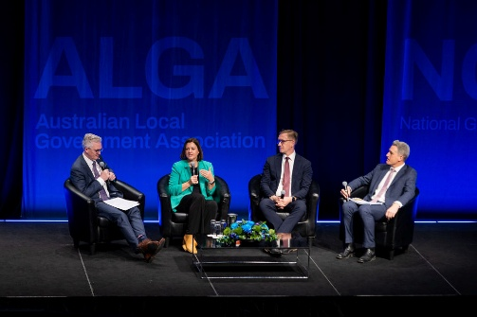

Firstly, Kirsty McBain, Minister for Emergency Management, Minister for Regional Development, Local Government and Territories, Josh Wilson, Assistant Minister for Climate Change and Energy, Assistant Minister for Emergency Management and Julian Hill, Assistant Minister for Citizenship, Customs and Multicultural Affairs, Assistant Minister for International Education. This session questioned when the sector would see some action coming from the Local Government Sustainability review, and why there was no local government representation on the Productivity Round Table that treasury have been consulting on. Neither topic received an answer with any substance or commitment. Questions from the floor were on a range of topics. Migration into the regions is seen as a challenge by Mr Julian Hill MP as Australia does not have enough cultural spaces for emigrants. People that have migrated to the regions then often feel separated from their culture and will move back to community hubs in larger cites. Councils were encouraged to welcome the families and spouses of migrant workforces to the community and make them feel at home as it makes it much more likely they will stay long-term.

Multiple Council delegates raised the need for more untied funding. Noting that while other levels of government were collecting more revenue than ever, councils were no longer receiving the one percent of federal revenue as they had in the past.

The panel responded that untied funding does not go where it is needed, although many Councillors disagreed with this in discussions over the next meal break. The needs of communities across Australia are diverse and each Council have community feedback showing that often grant money is not spent in a way community would like it to be due to the restrictions around the grant allocation. When asked how high on the list of things requiring reform to ensure productivity the panel pointed out the Government has doubled Roads to Recovery Funding and has the Safer Roads program.

Julian Hill MP highlighted that the home affairs department should take over the expense of delivering some Citizenship ceremonies, to help reduce the cost to Councils. Josh Wilson MP highlighted there would be a continued focus on renewable energy and storage, and improved energy performance.

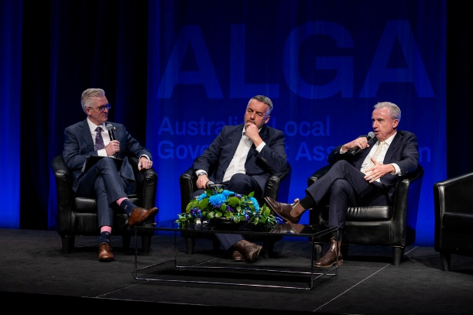Secondly, was Darren Chester, Shadow Minister for Veteran Affairs and Kevin Hogan, Deputy Leader of the National Party, Shadow Minister for Trade and Tourism. As well as questions on their own portfolios, these ministers were asked questions about the positions of their party and how to turn around the election defeat. It was concluded the Coalition would have to go back to the drawing board and address the election outcome and rebuild. During this session Darren Chester MP spoke about the Local Roads and Community infrastructure policy that was put in place by the Coalition. This scheme gave unattached funding that gave councils the flexibility to target what their community needs are. Both National members believed there needs to be more unallocated funding to local government to ensure they can get outcomes they need.

The election policy of the Coalition, Regional Futures Funds, was spoken of with the strong opinion that it should happen. The panel discussed that Regional Australia are the drivers of economy with exports. This fund would mean a lot more revenue for Regional Australia to improve funding for things such as hospitals and childcare, which would support communities who contribute to our economy through? exported products. The fund would be targeted with input from communities through advocacy from Local Government.

When questioned why the National Party do not support renewables more, both panellists argued that they had supported plenty of solar rebates and subsidies in the past. The Nationals are not opposed to small scale solar at all. However, they were not backing large scale renewables going through regional areas.

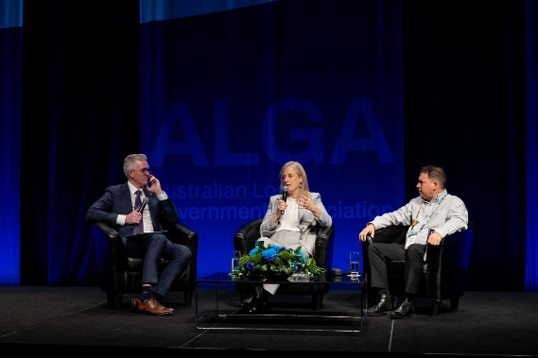Finally, was Katy Gallagher, Minister for Women, Minister for Government Services, Minister for Finance, Minister for the Public Service, Manager of Government Business in the Senate and ALGA President Matt Burnett. We were dismayed to hear Katy Gallagher, Minister for Finance, has not yet read the interim report on Local Government Financial Sustainability. When asked about the Governments ability to raise funding for Local Council Ms Gallagher noted that the Government needs to ensure that they are resourcing their election commitments and hope to identify spots where councils can assist with delivery of national strategies. Matt Burnett pointed out that more untied funding helps resolve the costs of grant writing and planning, as well as the administration burden of grant review and delivery, while Katy Gallagher MP accepted that Councils would like more untied funding and a pathway to one percent revenue. However, she noted if it was to be done there would need to be proven outcomes and delivery of national objectives in return for the increased funding. At the conclusion of these talks we left for the airport to head back to Melbourne before our long drive home.

Cr Sluggett and Cr Wilson sincerely thank CEO Gail Gatt for her input, discussion and support over the course of the event. During the Assembly Ms Gatt’s knowledge and insight into internal processes of the sector were extremely valuable, especially when considering motions.

For more information, including notes from the listening sessions, presentations and business papers (motions) please visit the National General Assembly 2025 webpage. https://conferenceco.eventsair.com/nga-2025