

PRIOR DAMAGE REPORT –
COUNCIL INFRASTRUCTURE

A Prior Damage Report is required for New Dwellings, Demolitions, Relocations, and New Commercial Buildings. This report should be provided to HRCC’s Building Department when your Building Permit is lodged.
Site Address: | Builder:
 | Builders Email Address:

Mark all pre-existing defects to kerb, channel, footpath, crossover, and pit covers below, noting location and extent. If required use the reverse of this sheet.
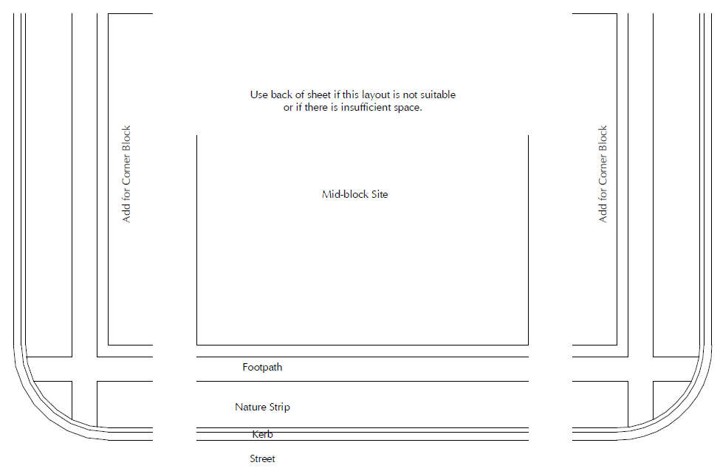

Please Note: If this report is not received prior to building work commencing, any existing damage will be attributed to the builder and the bond retained to offset the cost of rectification.

Report Completed by:

Office Use Only
Final Council Inspection | Return Deposit?
Signature: Date: | Yes / No

