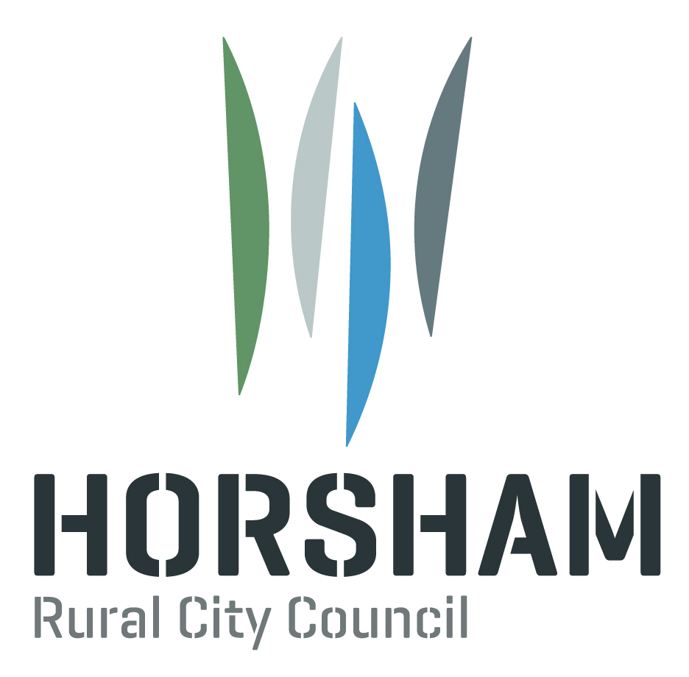

Terms of Reference

Disability Advisory Committee

Horsham Rural City Council

We have a *Disability Advisory Committee*

We will call it the committee.

People that know about disability can be on the committee.

The committee will share their experiences with Horsham Council.

The committee give ideas to Horsham Council.

These ideas help Horsham Council plan better for people with disability.

The committee will help Horsham Council to be more inclusive and accessible.

The committee will talk about barriers that people with a disability experience.

The Council will be told about what the committee talked about.

The committee does not talk about personal complaints.

The committee and members do not to talk to the media.

Members of the committee will be respectful of different ideas people have.

Things that the committee talk about are confidential.

There will be 10 members on the committee.

The members will be:

- People with a disability

- People that work in a disability type of job

- Carers of people with a disability.

To be on the committee you need to:

- Know about barriers that people with a disability experience

- Have ideas of what Horsham Council could do to be more inclusive

- Have an experience of disability

- Work well with others

- Think of the needs of the whole community

- Be fair

- Be a member for two years.

Horsham Council will say when they are looking for members to be on the committee.

Horsham Council will tell people in the newspapers, in
their newsletter and on their website.

Then people can tell Horsham Council they want to be on the committee.

People who want to be on the committee will have to apply to be a member.

Some people will be chosen to be on the committee.

Some people will not be chosen to be on the committee.

Meetings will be on every three months.

The committee will have a chairperson.

The chairperson will run the meetings.

